|  |  |
| --- | --- |
|  | **FPT ACADEMY INTERNATIONAL**  **FPT – APTECH COMPUTER EDUCATION** |

**Centre Name: ACE-HCMC-2-FPT.**

**Address: 590 Cach Mang Thang 8, District 3, Ho Chi Minh City, Viet Nam.**

**Persol**

|  |  |  |  |
| --- | --- | --- | --- |
| **Supervisor.** | Mr. Nguyen Phat Tai | | |
| **Batch.** | T1.2206.E1 | | |
| **Group.** | Group 2 | | |
| **Serial No.** | **Enrollment Number** | **Student Name** |
| 1. | Student1390589 | Le Viet Dong |
| 2. | Student1387826 | Huynh Tan Phuoc |
| 3. | Student1387816 | Tran Thu Huy |

September-2022

**This is to certify that**

**Mr./Ms.:**

Le Viet Dong

Huynh Tan Phuoc

Tran Thu Huy

**has successfully designed & developed**

eProject: Persol

**Submitted by: LE VIET DONG**

**Date of issue: 19-September-2021**

**Authorized Signature: Dong**

**TABLE OF CONTENTS**

FPT – APTECH COMPUTER EDUCATION 1

ACKNOWLEGMENT 3

SYNOSIS 3

PROBLEM DEFINITION 3

CUSTOMER'S REQUIREMENTS SPECIFICATIONS (CRS) 4

Business/Project Objective: 4

Hardware/ Software Requirements: 5

SCOPE OF THE WORK (IN BRIEF) 6

Architecture and design of the system 7

Diagram of the website 8

TASK SHEET REVIEW 1 9

MOCK OF THE WEBSITE 10

TASK SHEET REVIEW 2 17

WEBSITE DESCRIPTION 18

TASK SHEET REVIEW 3 34

# ACKNOWLEGMENT

On behalf of all the members of group 2, I would like to thank you all for the hard works, supports to make this eProject complete successfully. Especially, Mr. Nguyen Phat Tai, our teacher, he helped us a lot from the day that we started to study at FPT Aptech. With this eProject, he has guided us with his enthusiasm and rigorous. Thanks for his guiding, we would be able to finish this project. Besides, I want to thank all the team member of group 3, each of the team members has been working continuously in 4 weeks in order to complete this project. The last but not least, we would like to say thank you to our family for always supporting us, creating the best conditions for us to focus on the project, and putting faith in the dreams we pursue.

# SYNOSIS

Persol has a large collection of Frames and lenses. The company advertises by distributing the pamphlets, advertising on television and so on. Due to rapid development in internet field, the company decides to launch a website where people will get all the information about the various products available with them easily.

We will create a Single-Page-Application and responsive Website for them with the below mentioned requirement specifications.

The website is to be developed for the Windows Platform using HTML5, JSON, Angular JS, JavaScript and Geolocation. The site should work well in all leading browsers including Chrome, IE, Firefox etc.

# PROBLEM DEFINITION

The Web site is to be created based on the following requirements.

1. The Top of the Page should contain logo of the site with suitable images.
2. The site should display a menu which will contain the options for brief introduction about the various frames and lenses available, location of the shop and any other information if required.
3. The information should be categorized according to the brand names of the products like if a User wants to see only “Ray-Ban” products or any other companies products then he/she can click on a Link/button/menu etc and can see only that Brand products.
4. Another category option for “Contact Lenses”, “SunGlasses” etc. should be created and accordingly the products should be listed.
5. When a user selects any particular brand, a list of products for that brand will be displayed
6. A brief summary of features of individual products should be displayed on the Web Page along with the product but detailed Features should be stored in Individual Word documents which can be downloaded or viewed by the User who wishes to see the same.
7. The user should also be able to compare the various products of different as well as similar brands.
8. There should be a “Contact Us” page which will have the Address of the Company which is as follows and the mail address which when clicked will invoke the local mail client from where they can send an email. Address of the Company should be displayed using GeoLocation API (eg. GoogleMaps).

# CUSTOMER'S REQUIREMENTS SPECIFICATIONS (CRS)

**Client: Persol**

### Business/Project Objective:

* Display a continuous scrolling ticker at the bottom of the page with current date, time, and location (hint: Use geolocation features of HTML5).
* Display a visitor count at the top right corner of the page beside a logo image.
* The menu options should change color on hover and also after clicking.
* Fade in and fade out options can be used for the menus

**Input to the system:**

* + - * Browsing products based on brands, type of glasses products.

**Output from the system:**

* A menu that will categorize all the functions of the site.
* Display the list of available albums category wisely.
* Perform the search based on a particular: brands, type of glasses products.
* Site should be able to provide brief introduction/history about the company under About Us page.
* The location of the company under Contact-Us page.
* Besides the above requirements, the site should have look and feel as per the industry standards.

**Expected delivery date:** 19-Sep-2021.

**List of deliverables:**

* + - * Document Word.
      * User Guide.
      * Source code.

### Hardware/ Software Requirements:

* **For developer**

**Hardware**

* Intel Core i3/i5 Processor or higher
* 8 GB RAM or above
* Color SVGA
* 500 GB Hard Disk space
* Mouse
* Keyboard

**Software**

Technologies to be used:

* Frontend: HTML5, CSS, Bootstrap, JavaScript, jQuery, AngularJS, XML
* Data Store: JSON files or TXT files .

Other Requirements:

* Operating Portal: Windows
* Browsers: Edge, Chrome, Mozilla Firefox, Safari

# SCOPE OF THE WORK (IN BRIEF)

After a long and detailed discussion, our group has decided to create a website contain the following webpages:

1. ***Homepage***: Display information about newest-selling products, an introduction about insurance products.
2. ***Brands***: Display all models of brands based on category (Ray-ban, Okley, Porsche Design, Burberry, etc.).
3. ***Type of galasses Products***: Sunglasses, Frames, Lenses,..
4. ***About Us***: Display the information of the company and about us.
5. ***Contact***: Display the address of the company, allow customers to request any information
6. ***Compare***: Providing a clear view to the customer for brief comparison of 2 products among those on sale

# Architecture and design of the system

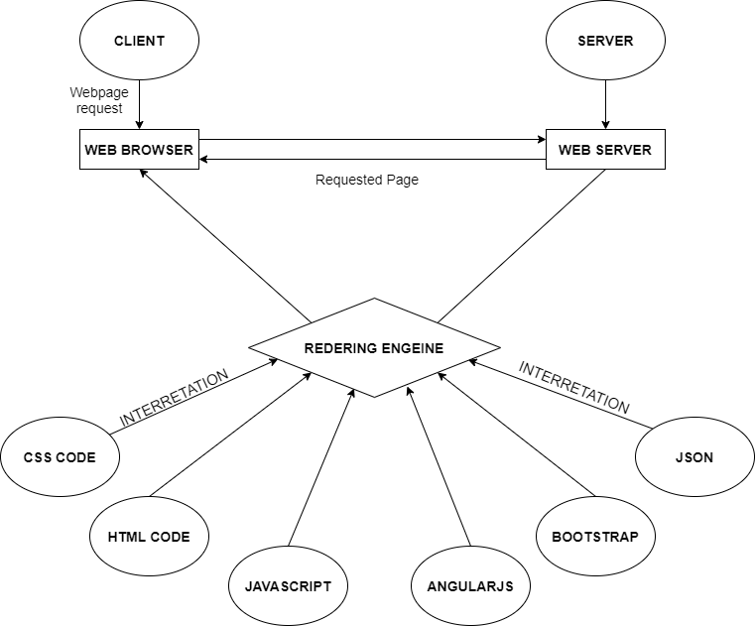

# Diagram of the website

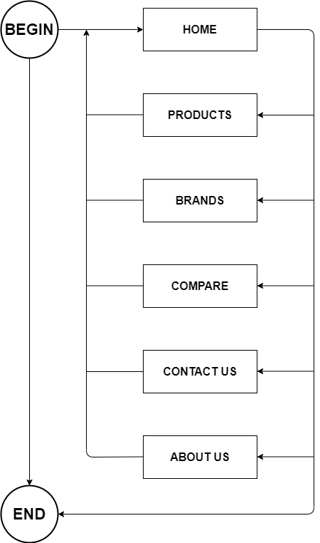

# TASK SHEET REVIEW 1

|  |  |  |  |  |  |  |  |
| --- | --- | --- | --- | --- | --- | --- | --- |
| **Project Ref. No.:**  **eP/Advertisement Portal Management**  **System/01** | | **Project Title:** | **Activity Plan Prepared By:** | **Date of Preparation of Activity Plan:** | | | |
| **Sr.**  **No.** | **Task** | **Actual**  **Start Date** | **Actual Days** | **Team**  **Mate Names** | **Status** |
| 1 | Problem Statement | Persol | Dong | 17-Sep-2022 | 1 | Dong | Completed |
| 2 | Analysis of Glasses requirements about the website | 17-Sep-2022 | 1 | Phuoc | Completed |
| 3 | The scope of the work (in brief) | 17-Sep-2022 | 1 | Huy | Completed |
| 4 | Architecture and design of the system | 17-Sep-2022 | 1 | Dong | Completed |
| 5 | Diagram of the website | 17-Sep-2022 | 1 | Huy | Completed |
| 6 | Task Sheet | 17-Sep-2022 | 1 | Phuoc | Completed |
| 7 | Mock of The Website |  |  | 17-Sep-2022 | 1 | Dong | Completed |

|  |  |
| --- | --- |
| **Date: 17-Sep-2021** | |
| Signature of Instructor:  **Mr. Nguyen Phat Tai** | Signature of Team Leader:  **Mr. Le Viet Dong** |



# MOCK OF THE WEBSITE

1. **HOME PAGE**

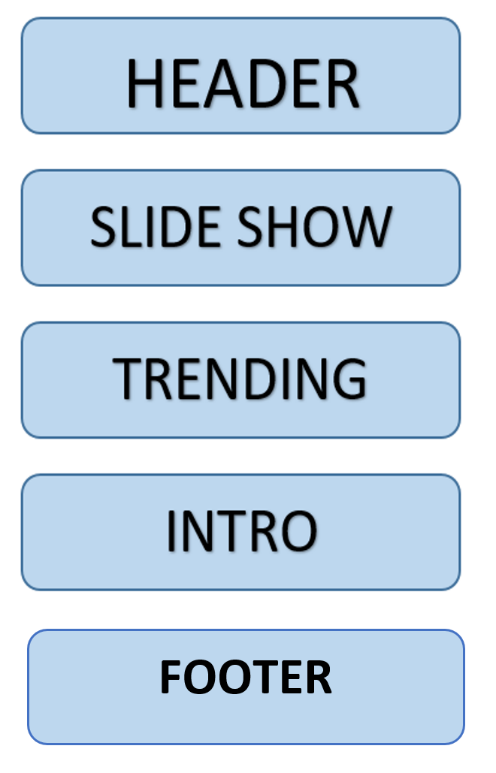

1. **BRANDS**

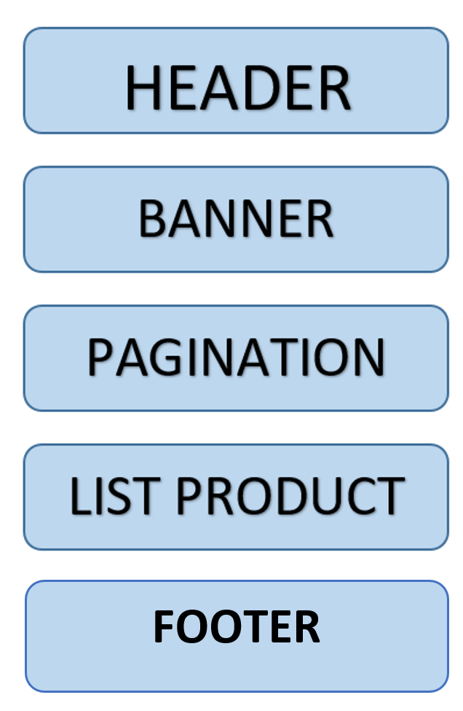

1. **SUNGLASSES, GLASSES, COMPARE**

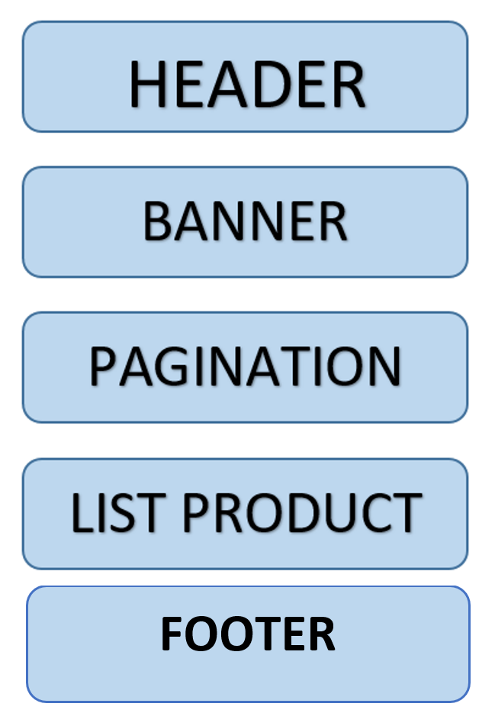

1. **ABOUTS**

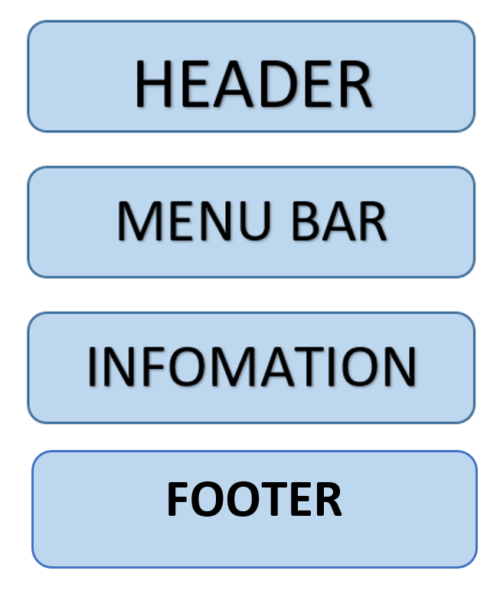

1. **CONTACT US**

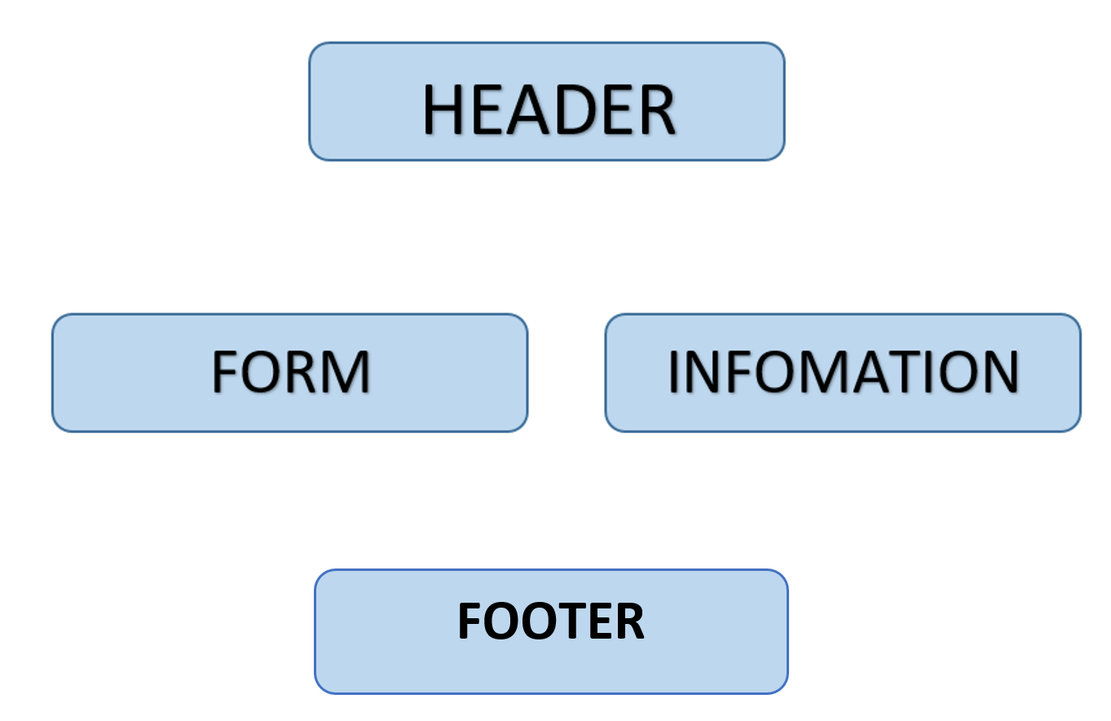

1. **COMPARE**

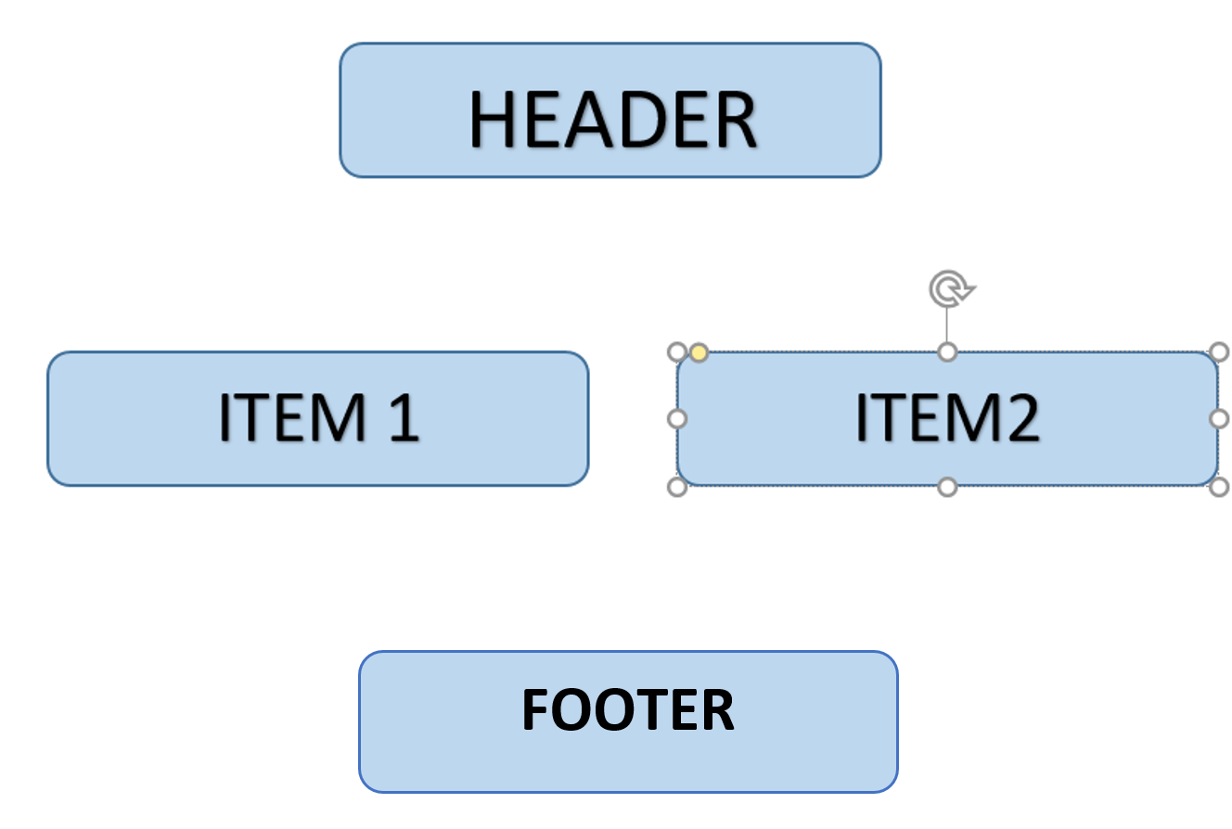

**SITE MAP**

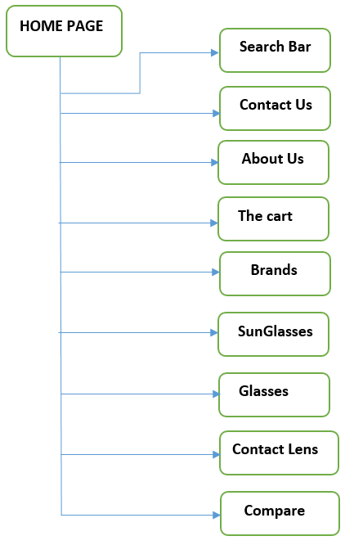

# TASK SHEET REVIEW 2

|  |  |  |  |  |  |  |  |
| --- | --- | --- | --- | --- | --- | --- | --- |
| **Project Ref. No.:**  **eP/Advertisement Portal Management**  **System/01** | | **Project Title:** | **Activity Plan Prepared By:** | **Date of Preparation of Activity Plan:** | | | |
| **Sr.**  **No.** | **Task** | **Actual**  **Start Date** | **Actual Days** | **Team**  **Mate Names** | **Status** |
| 1 | Json | Persol | Phuoc | 28-Sep-2022 | 1 | Dong | Completed |
| 2 | Banner | 28-Sep-2022 | 1 | Huy | Completed |
| 3 | Home | 28-Sep-2022 | 1 | Phuoc | Completed |
| 3 | Task Sheet | 28-Sep-2022 | 1 | Phuoc | Completed |

|  |  |
| --- | --- |
| **Date: 28-Sep-2021** | |
| Signature of Instructor:  Tai  **Mr. Nguyen Phat Tai** | Signature of Team Leader:  Dong  **Mr. Le Viet Dong** |

# 

# WEBSITE DESCRIPTION

1. **HOME PAGE:**

* Description

Home page displays following information:

* Slideshows of the news about Glasses.
* Current top selling products of shop.
* Footer contains links to company’s social platforms.
* Show the time and location of the shop in the right corner.
* Screenshot

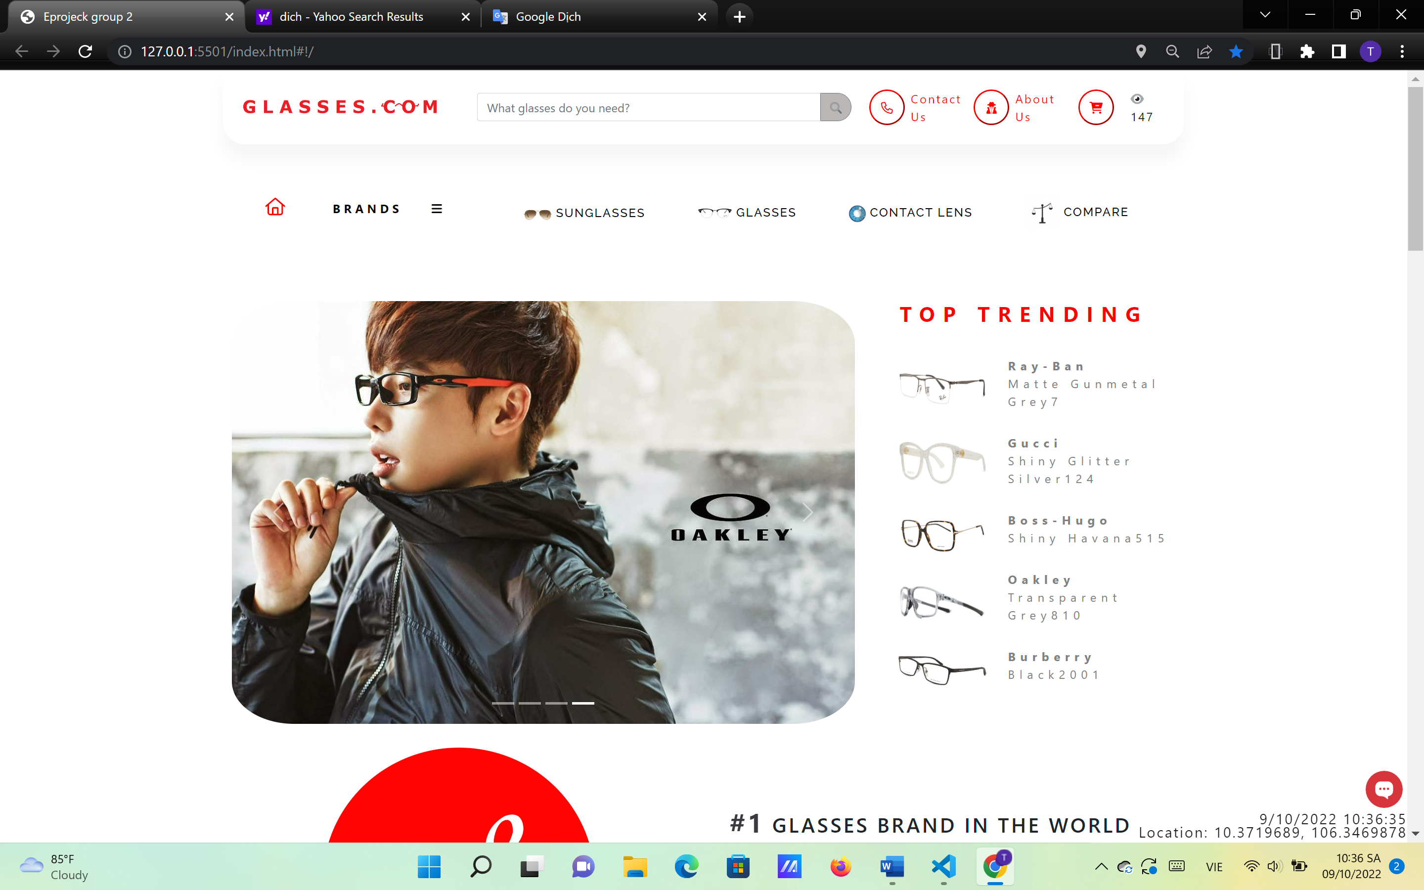

**Figure 1.1:** Homepage slideshow, top trending and time, location of the shop

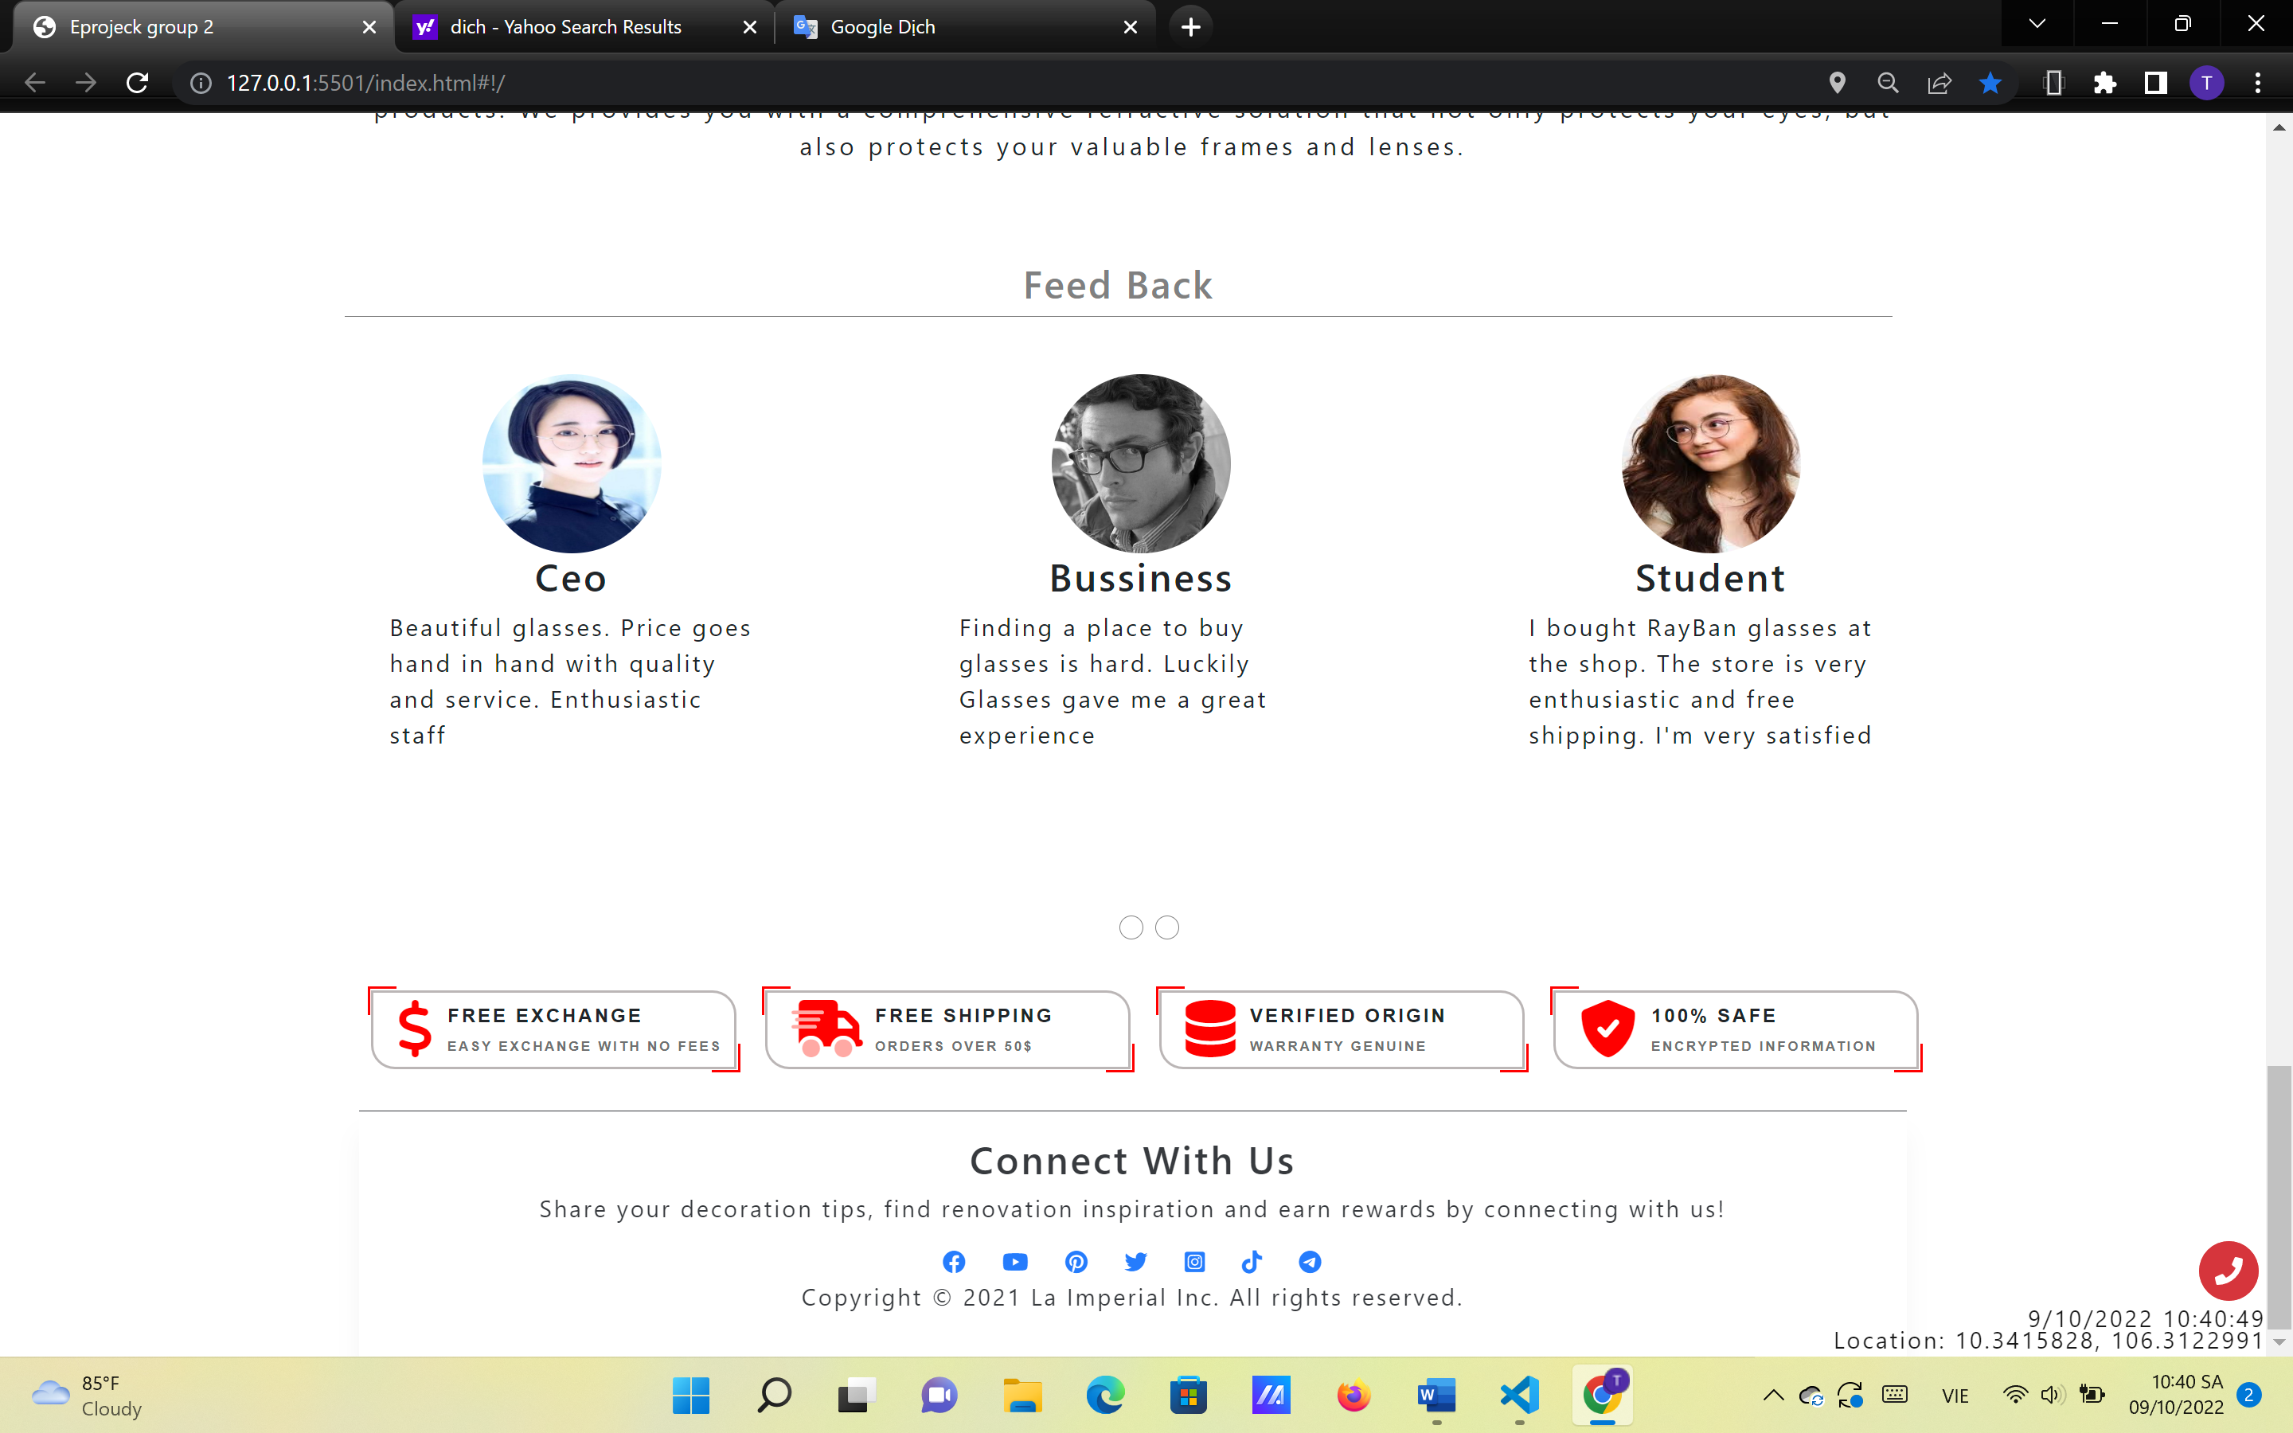

**Figure 1.2:** Footer

1. **PRODUCTS:**

* Description

This page contains various products with their information sorted by their type (glasses, sunglasses, contact lens). People can also search products by their names or prices and filter them. The details products will be shown when clicking on them. A Word document containing detailed information of each product can be downloaded by clicking a button the detailed product page.

* Screenshot

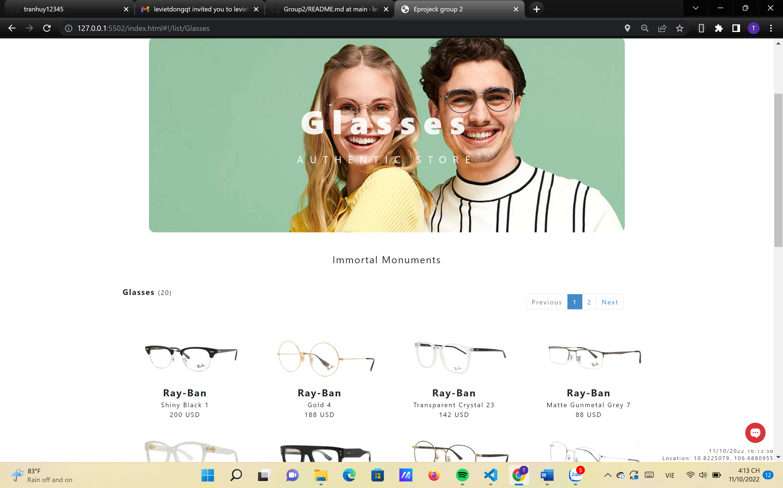

**Figure 2.1:** Glasses

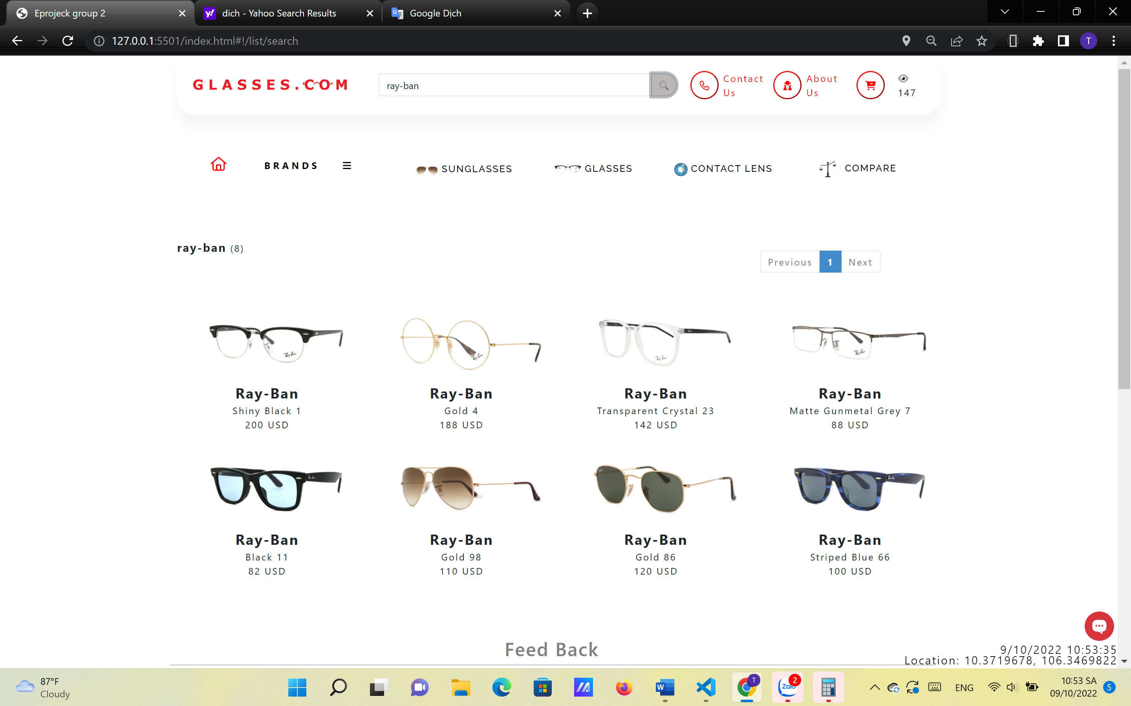

**Figure 2.4:** Search “Ray-ban” products sorted by ascending price

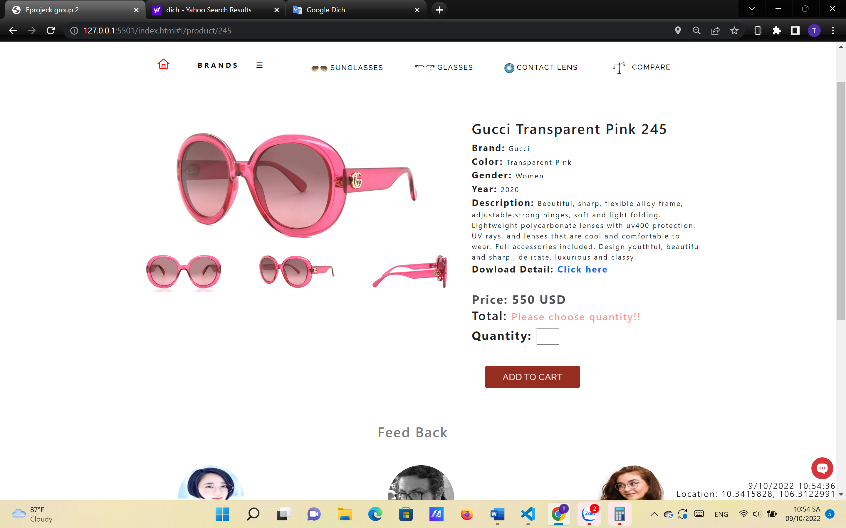

**Figure 2.5:** Product detailed information with a download button to the Word document

1. **BRANDS AND CART:**

* Description

This is also a page of products on sale with details but sorted by brands of the products (Ray-ban, Oakley, Gucci). The details products will be shown when clicking on them. A Word document containing detailed information of each product can be downloaded by clicking a button the detailed product page.

* Screenshot

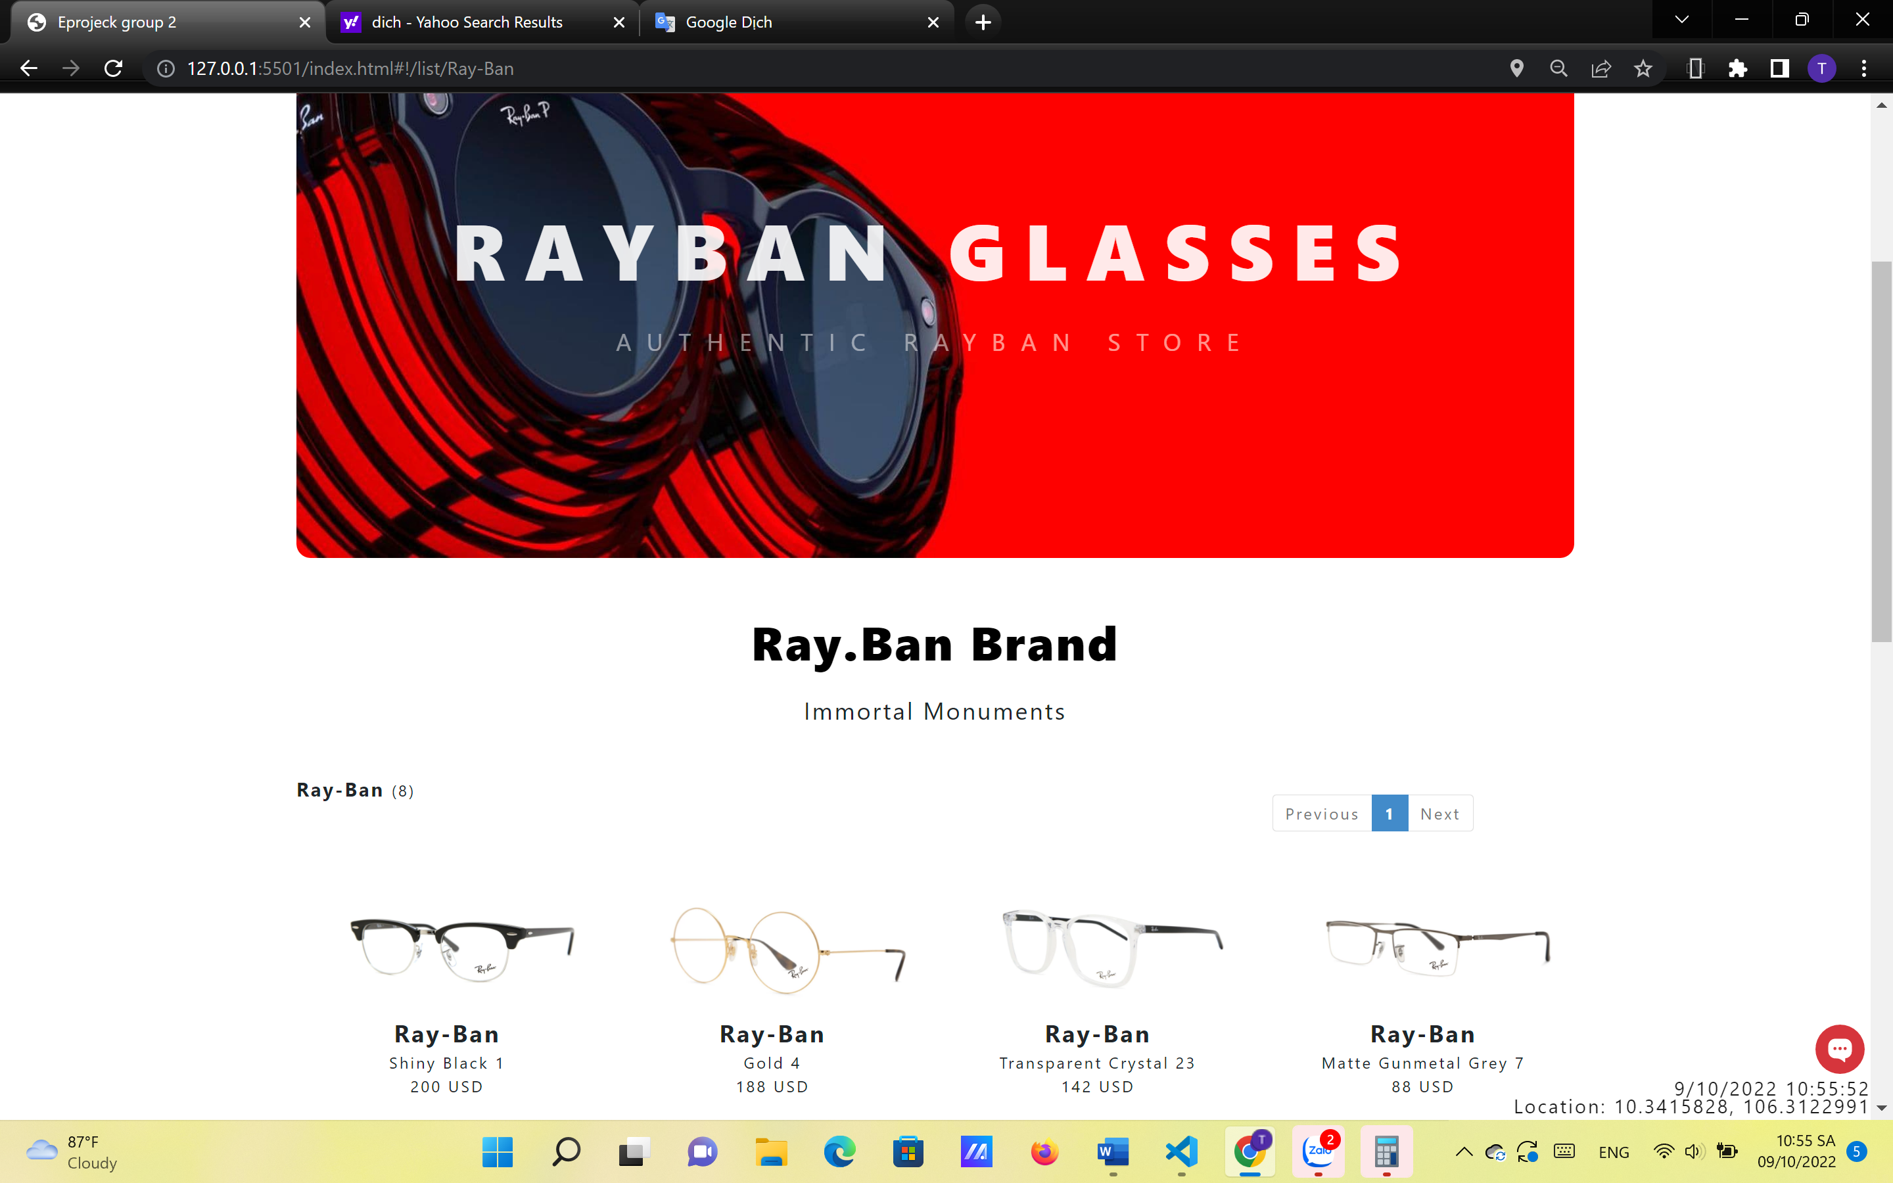

**Figure 3.1:** Ray-ban

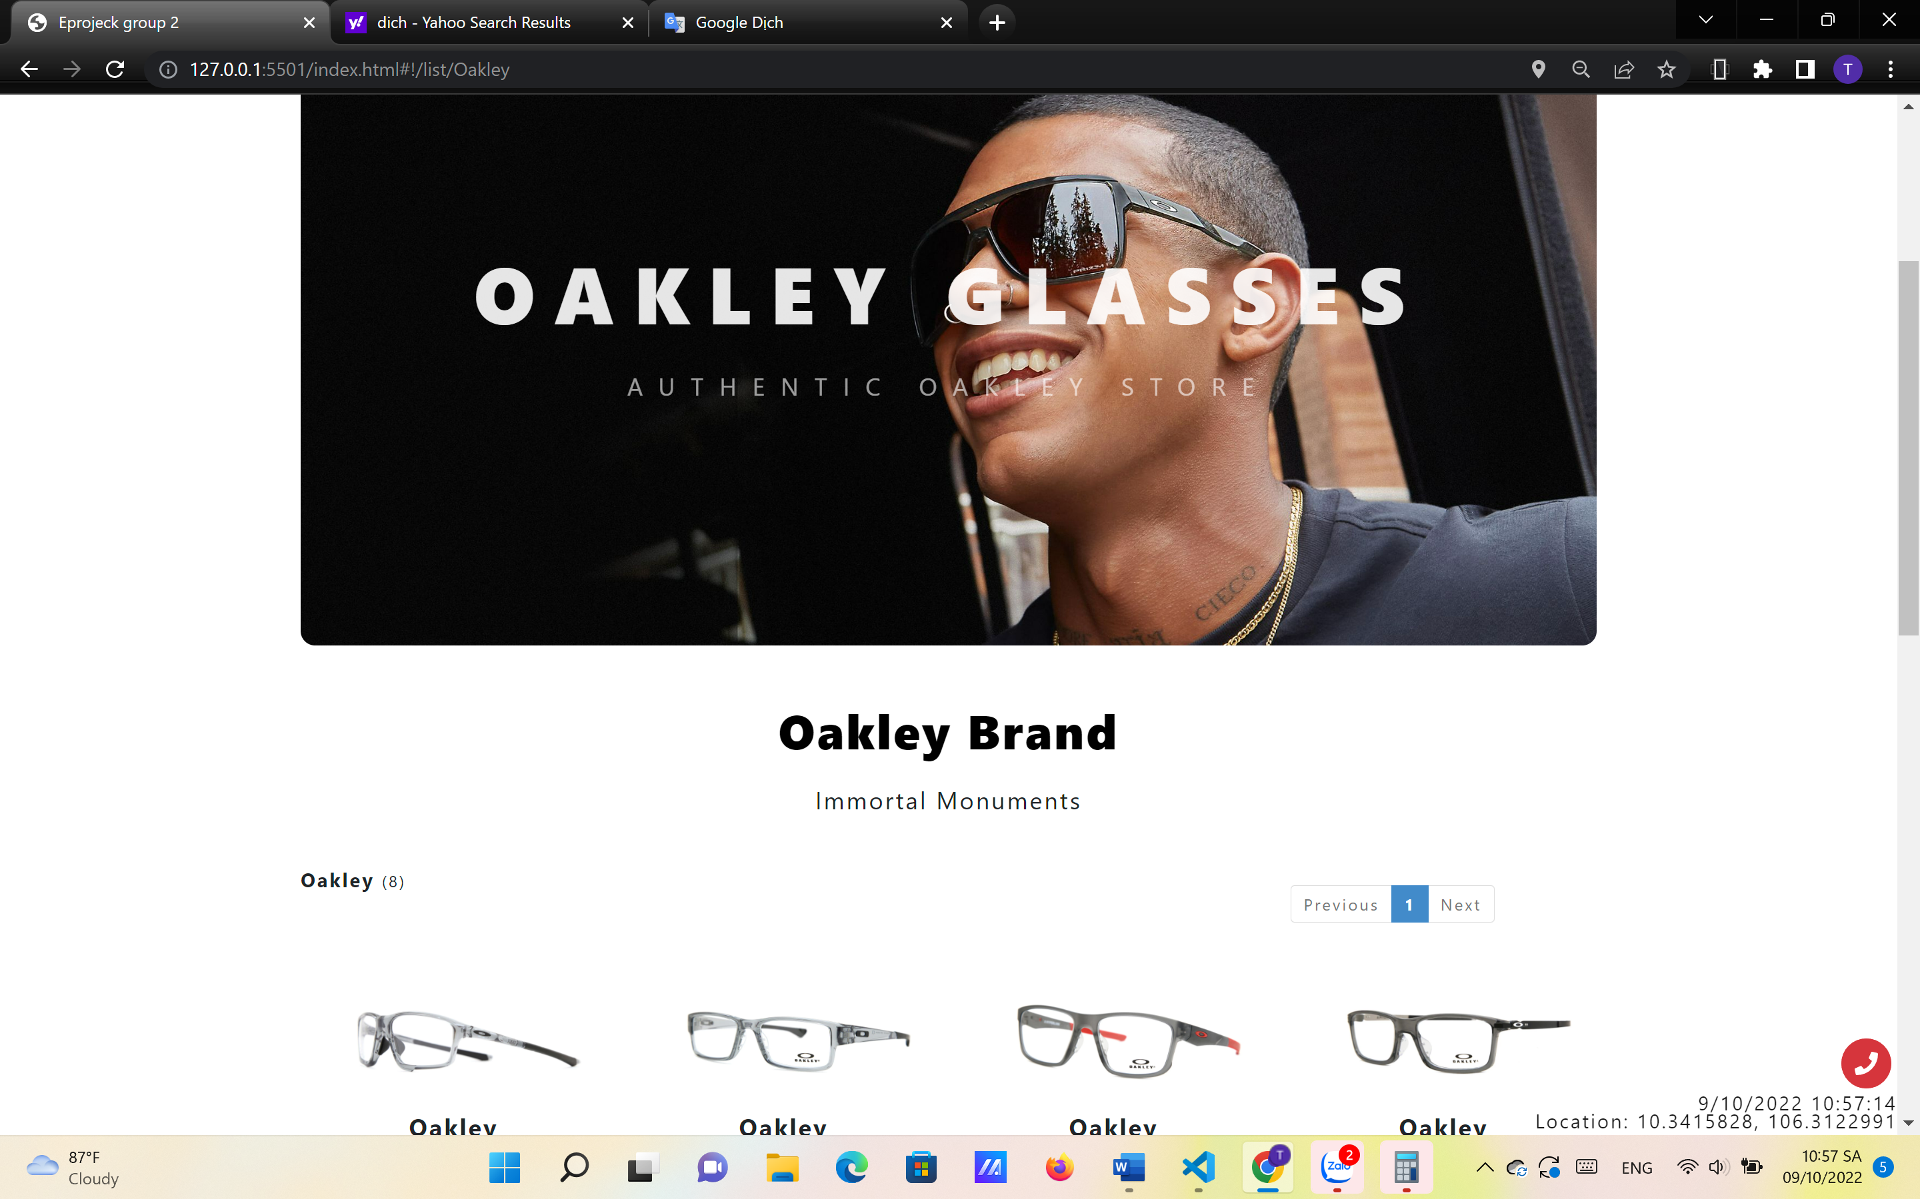

**Figure 3.2:** Oakley

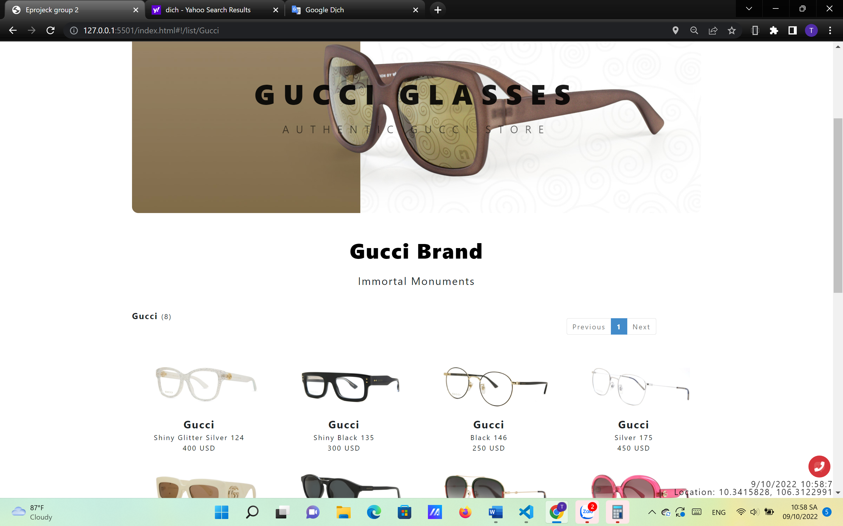

**Figure 3.3:** Gucci

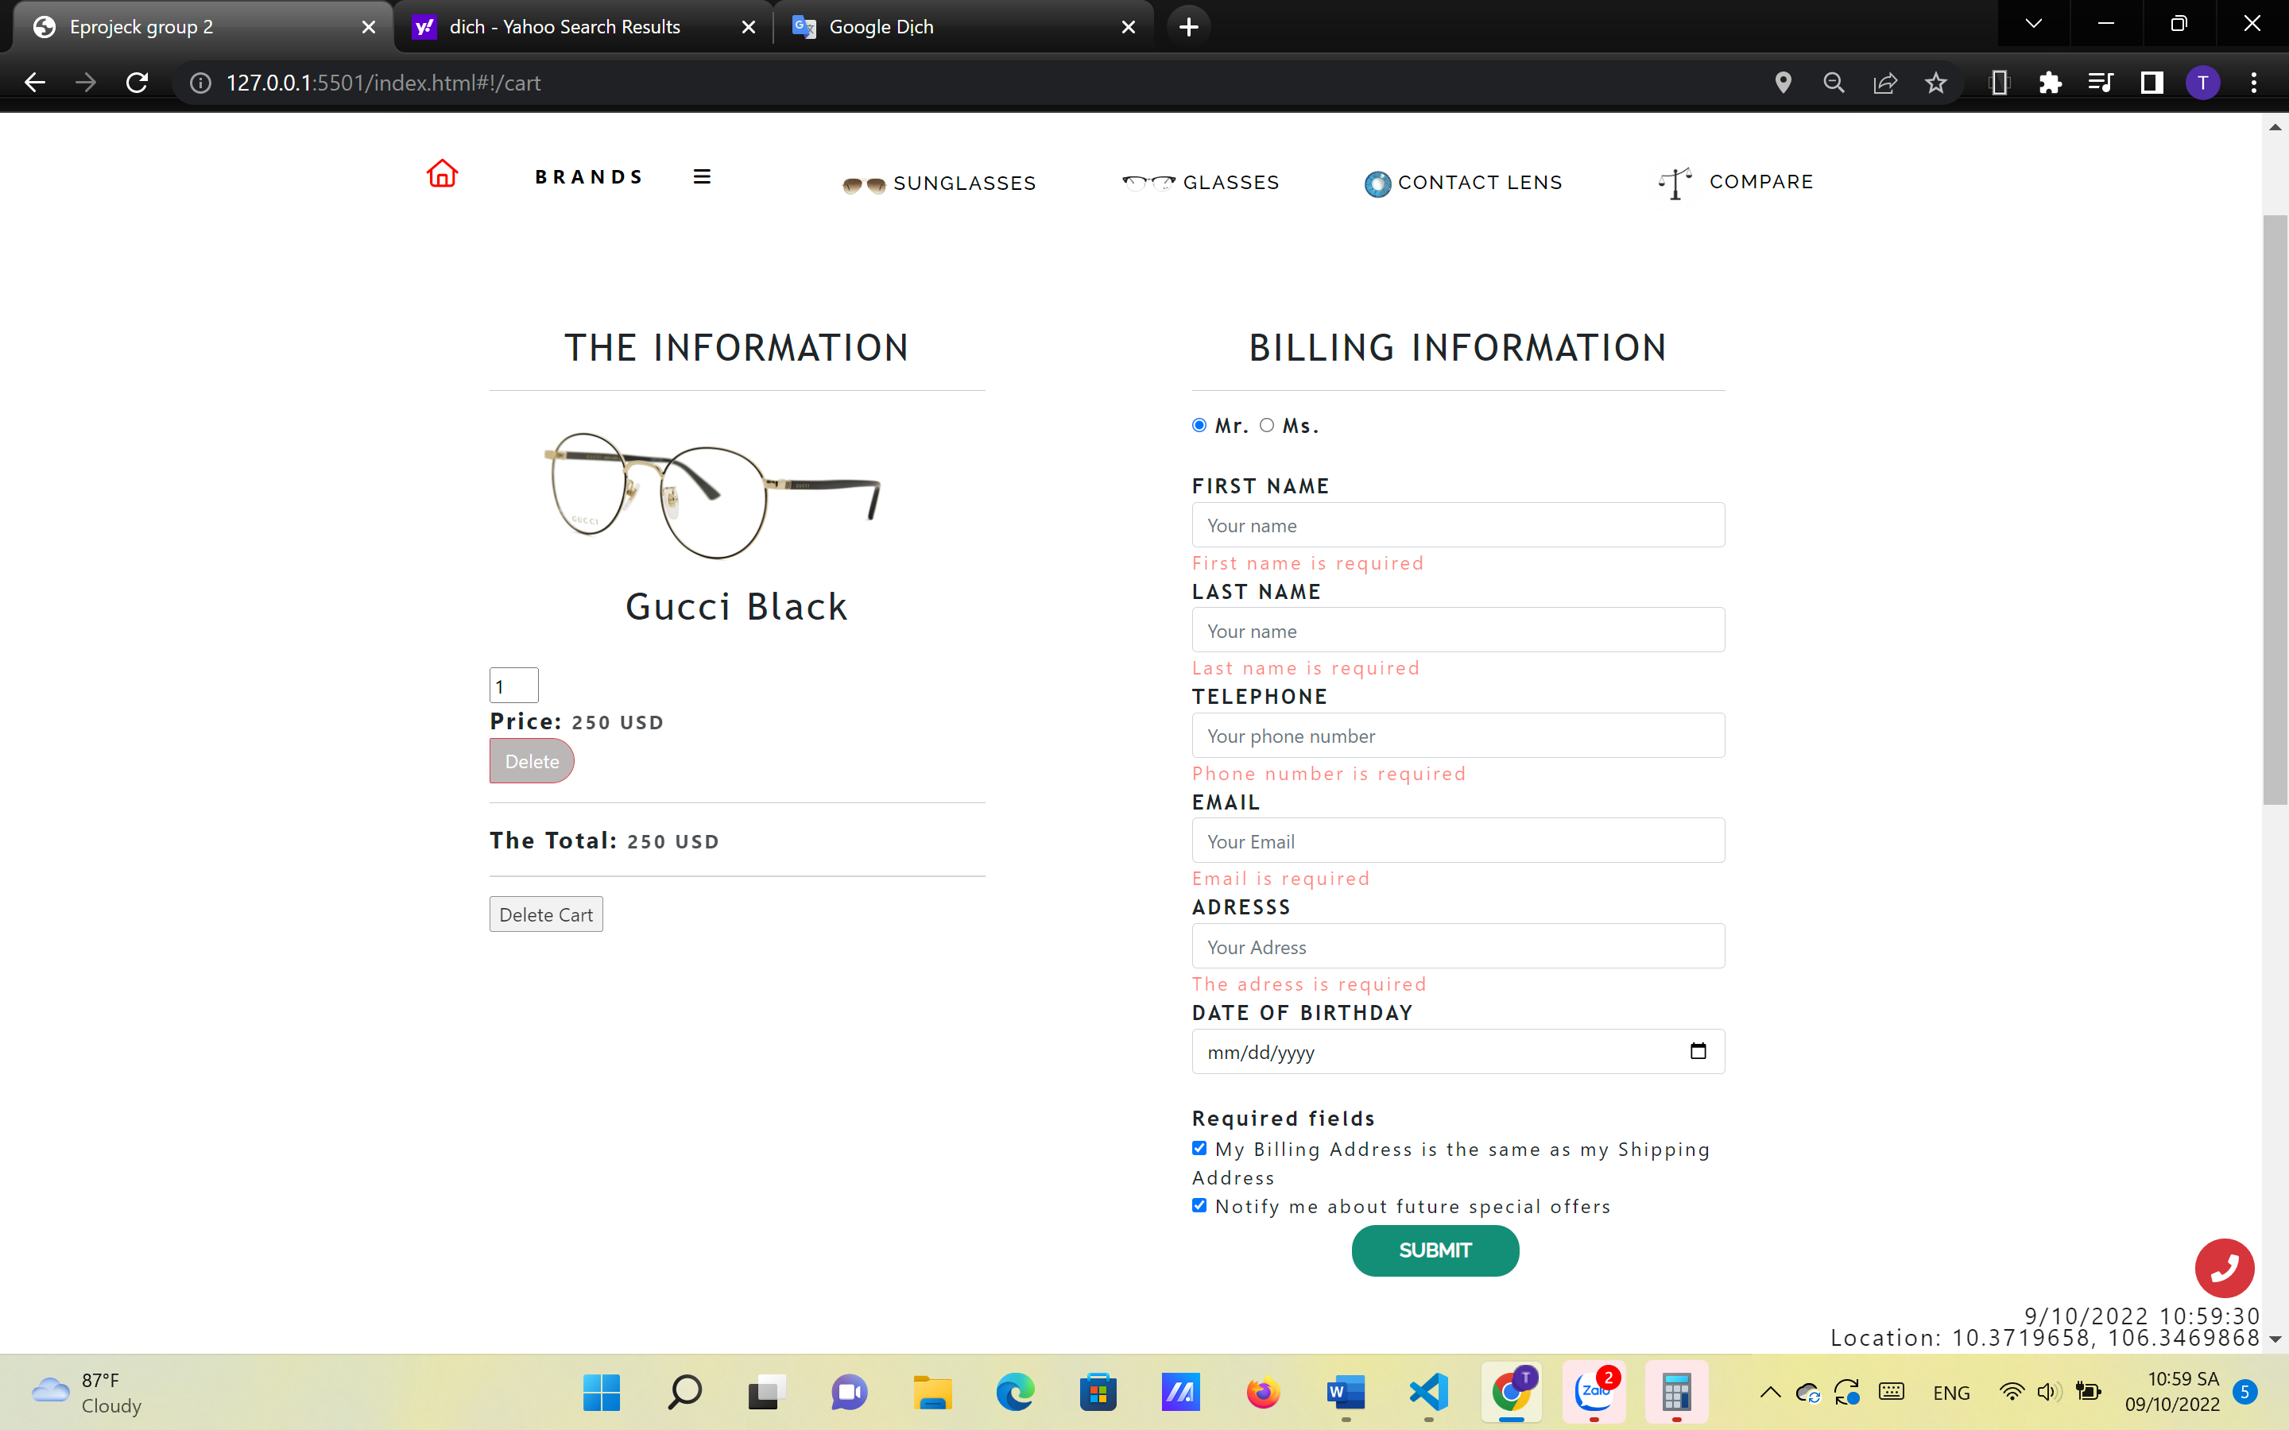

**Figure 3.5:** Cart information

1. **COMPARE PAGE:**

* Description:

Customers can compare visually 2 products by selecting their brand, names and click Filter. All the details information of those products will be displayed.

* Screen shot:

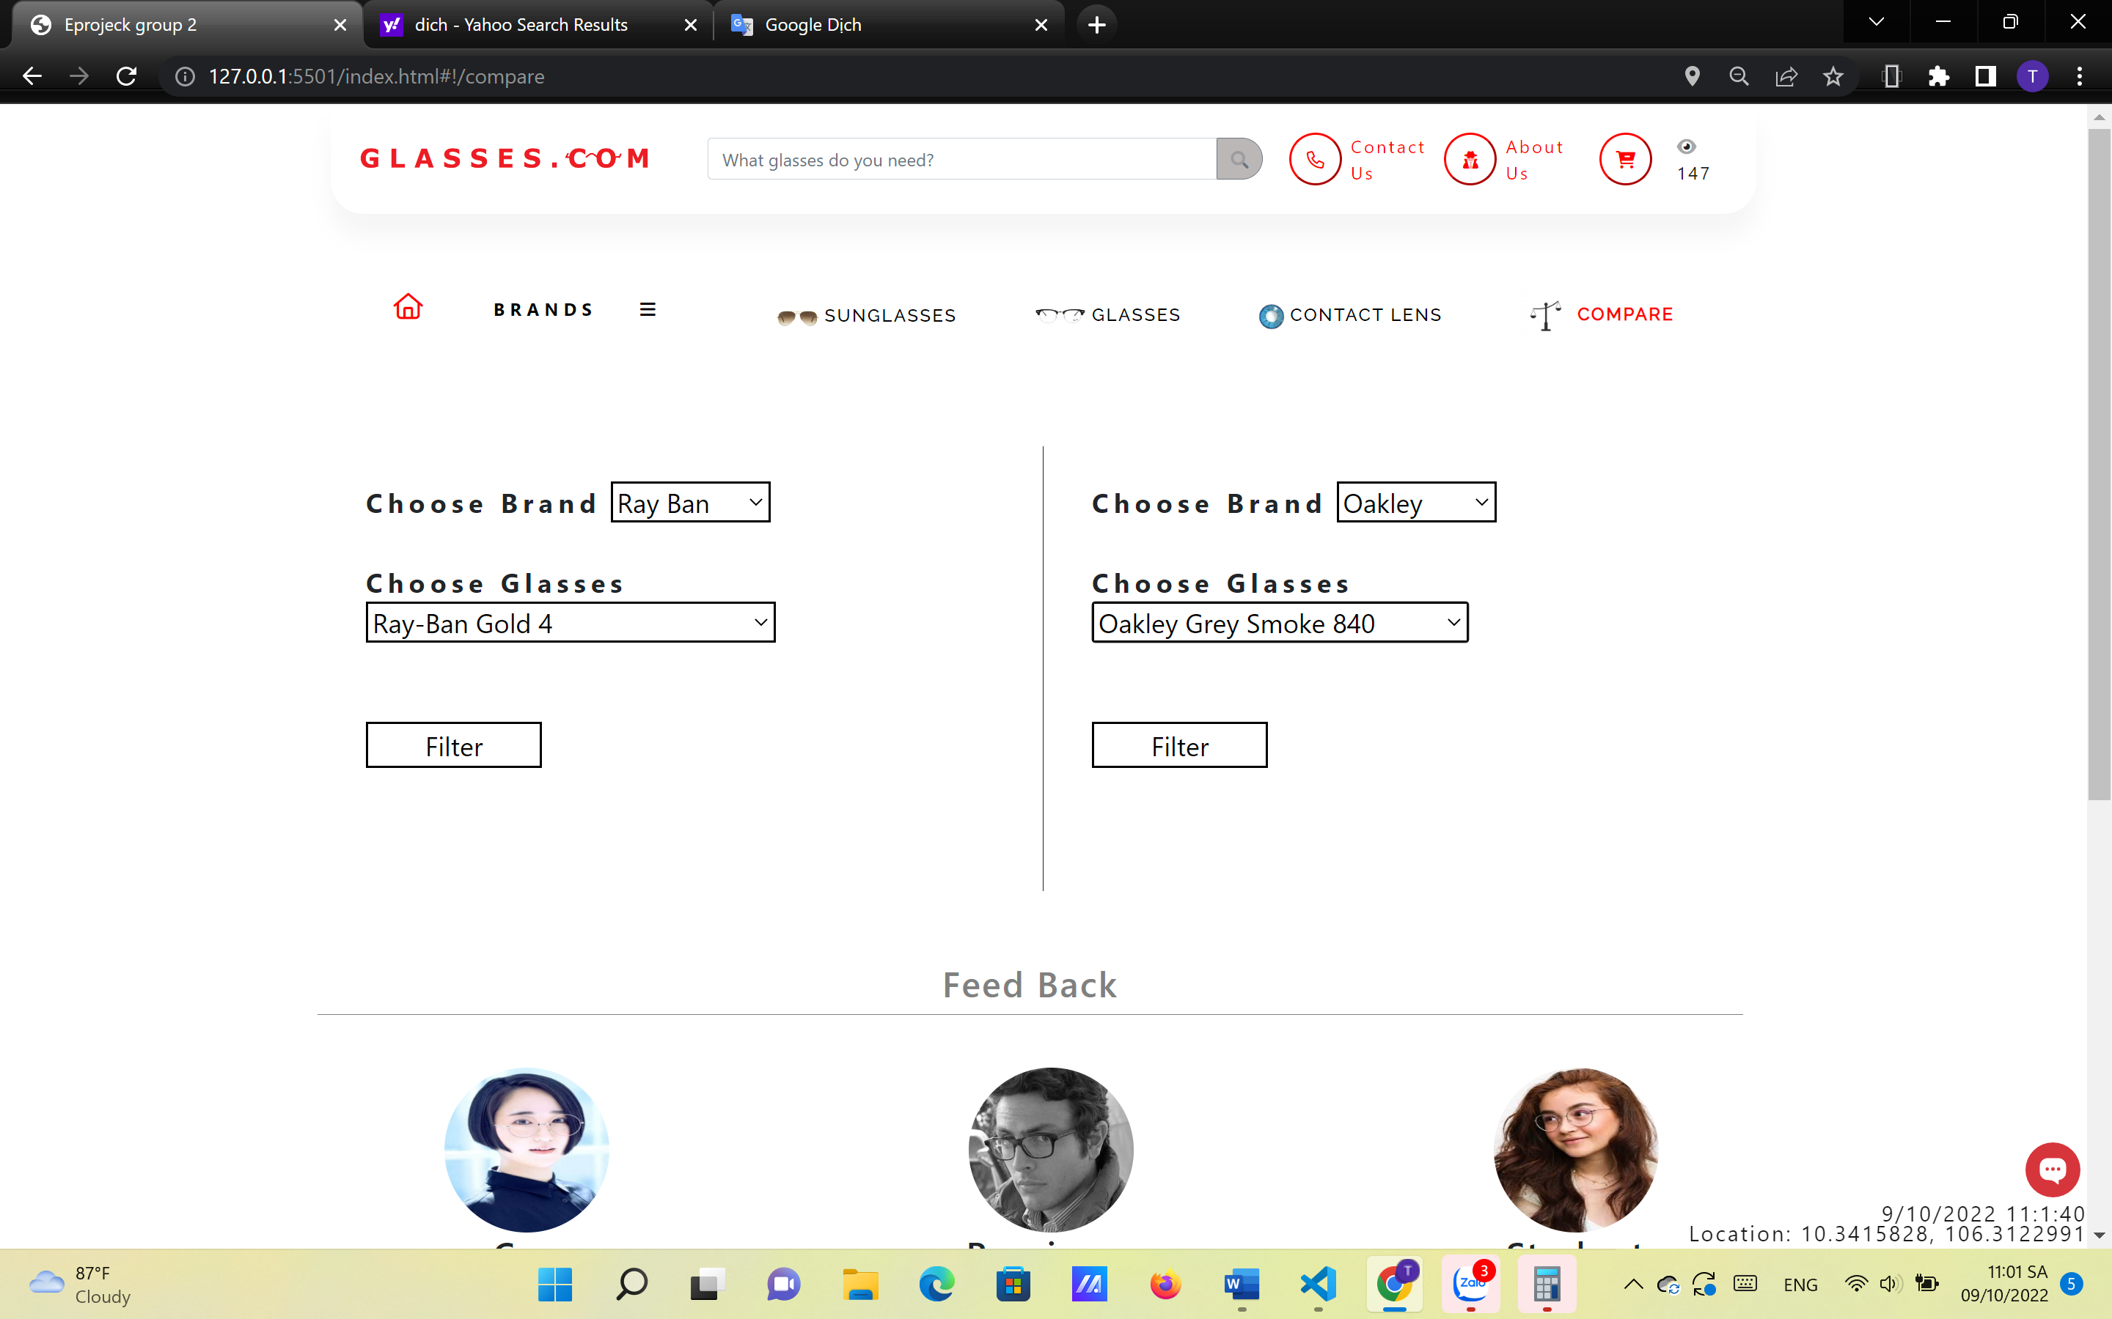

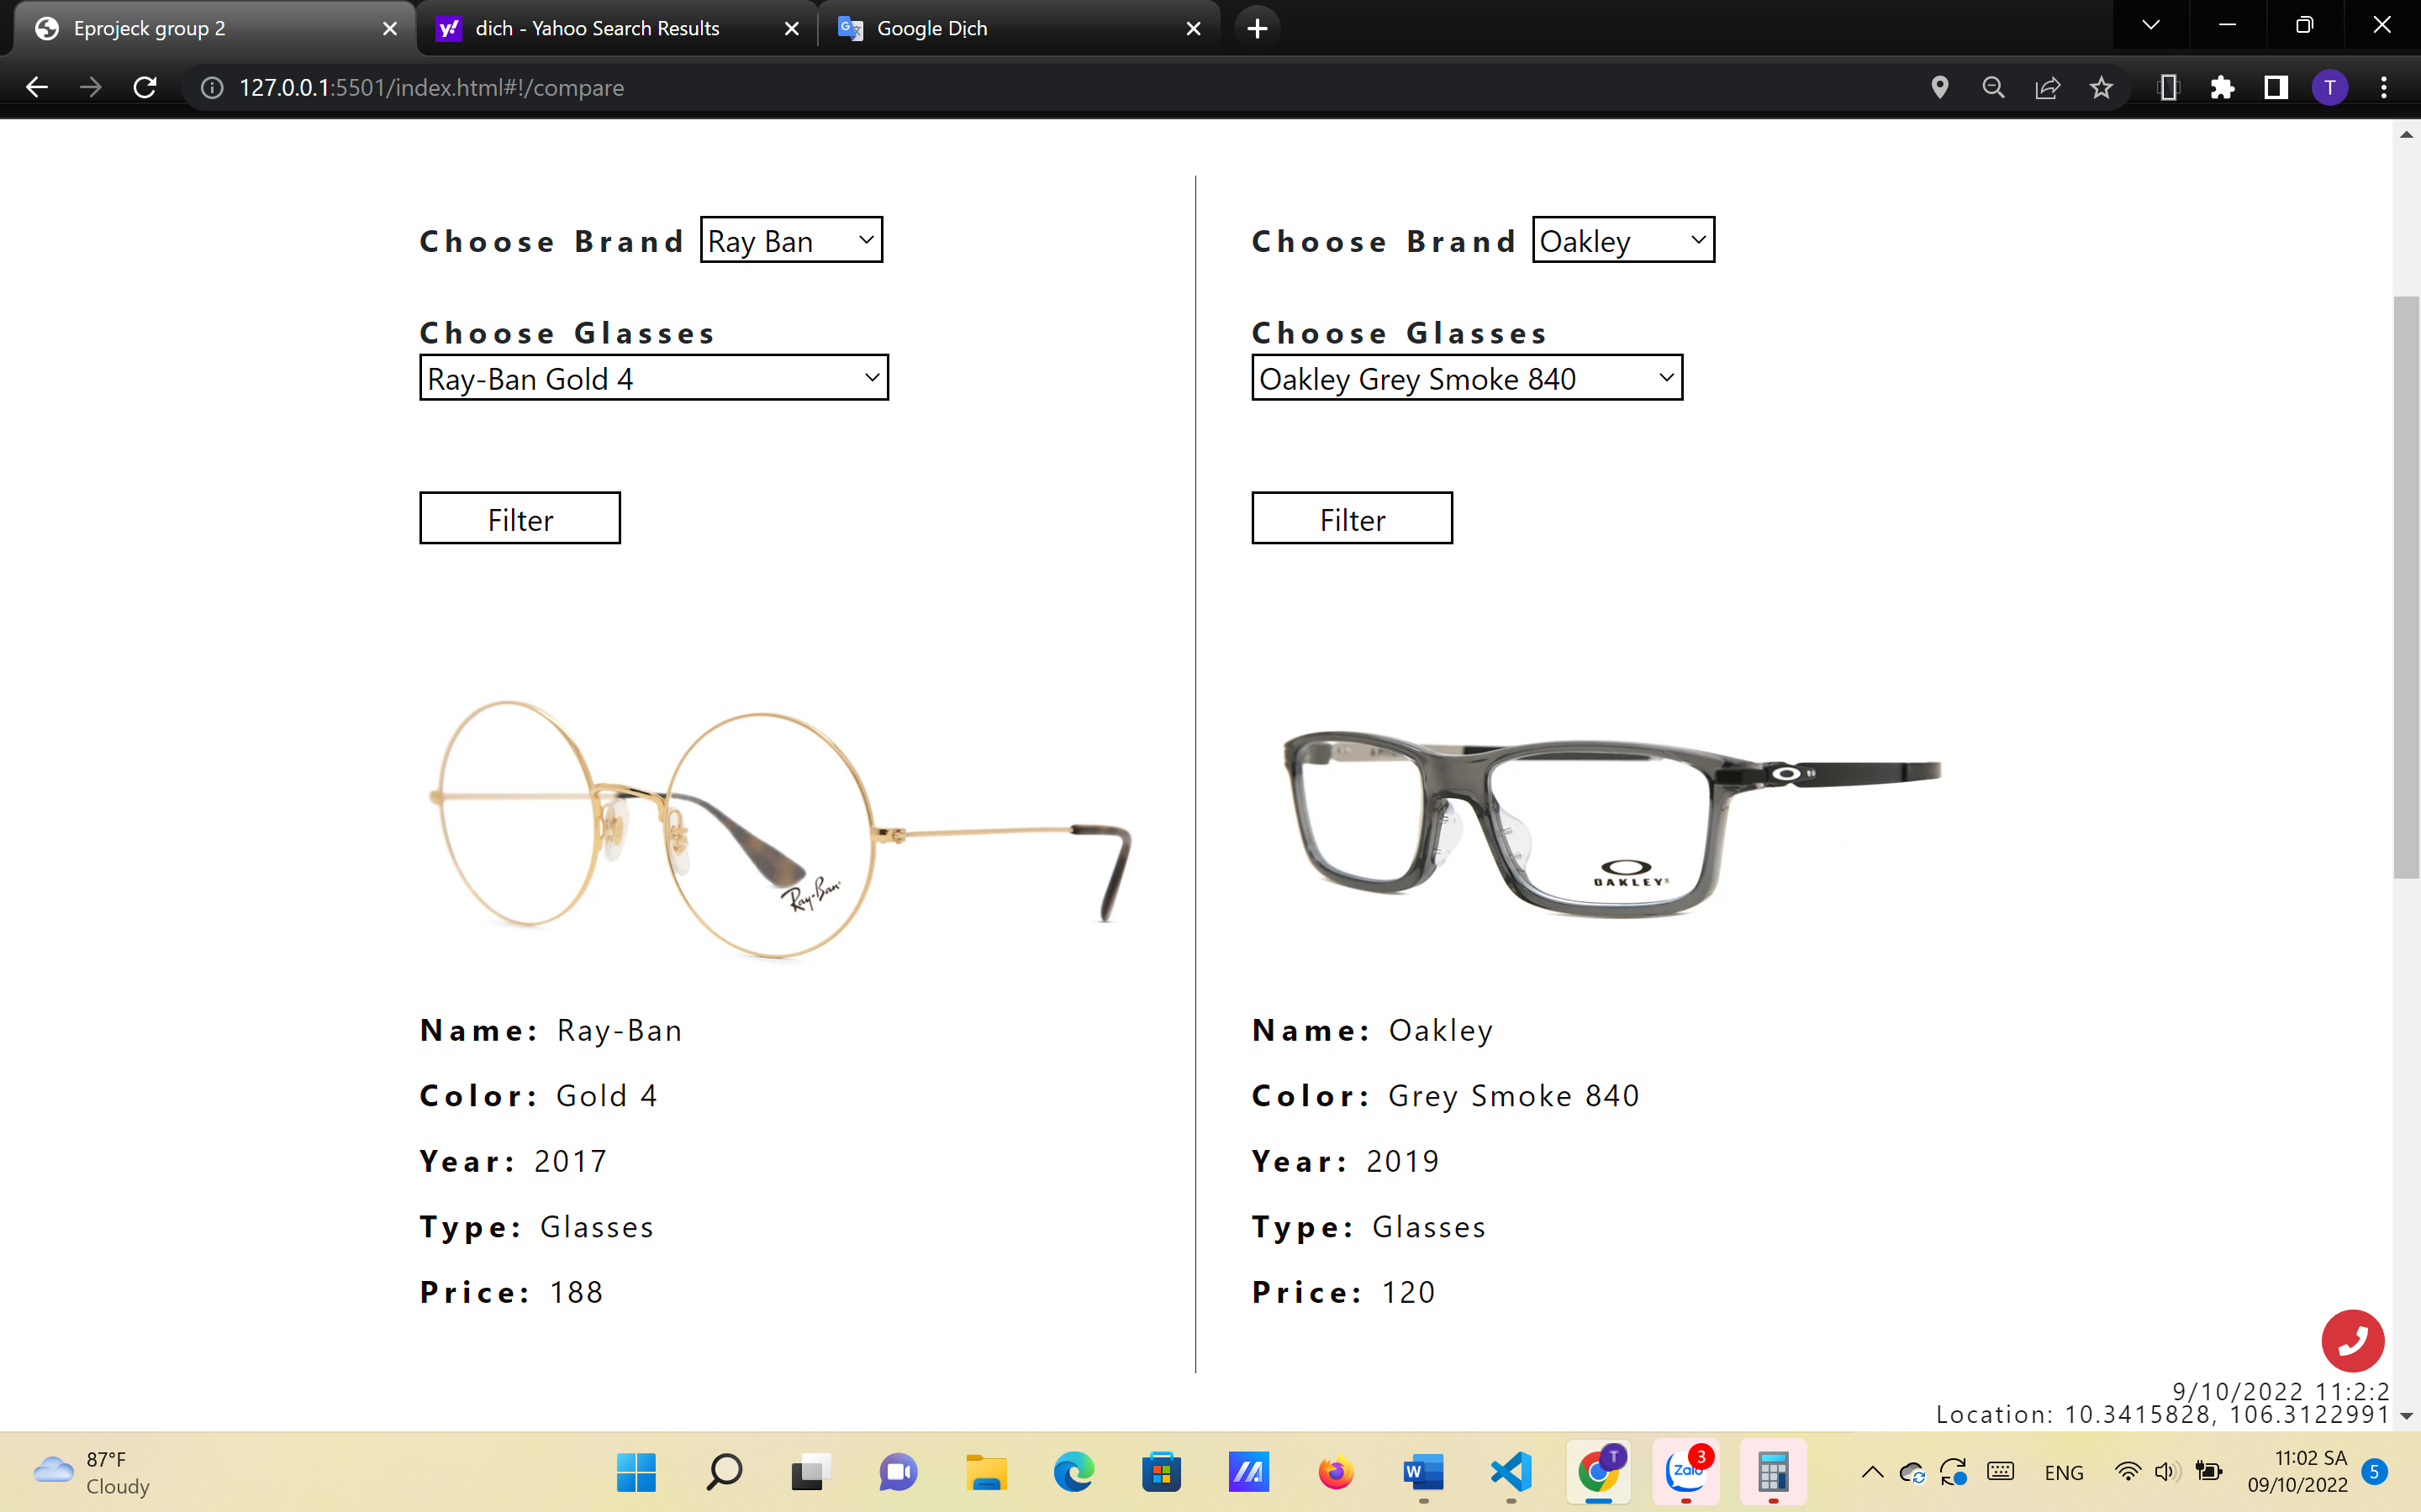

1. **ABOUT US PAGE:**

* Description:

This is the page about the history and the scope of the company. This include the important milestones of the company’s lifetime up to now. It also shares some stories about the development of Glasses.com and also the scope, the vision in the future.

* Screen shot

1. 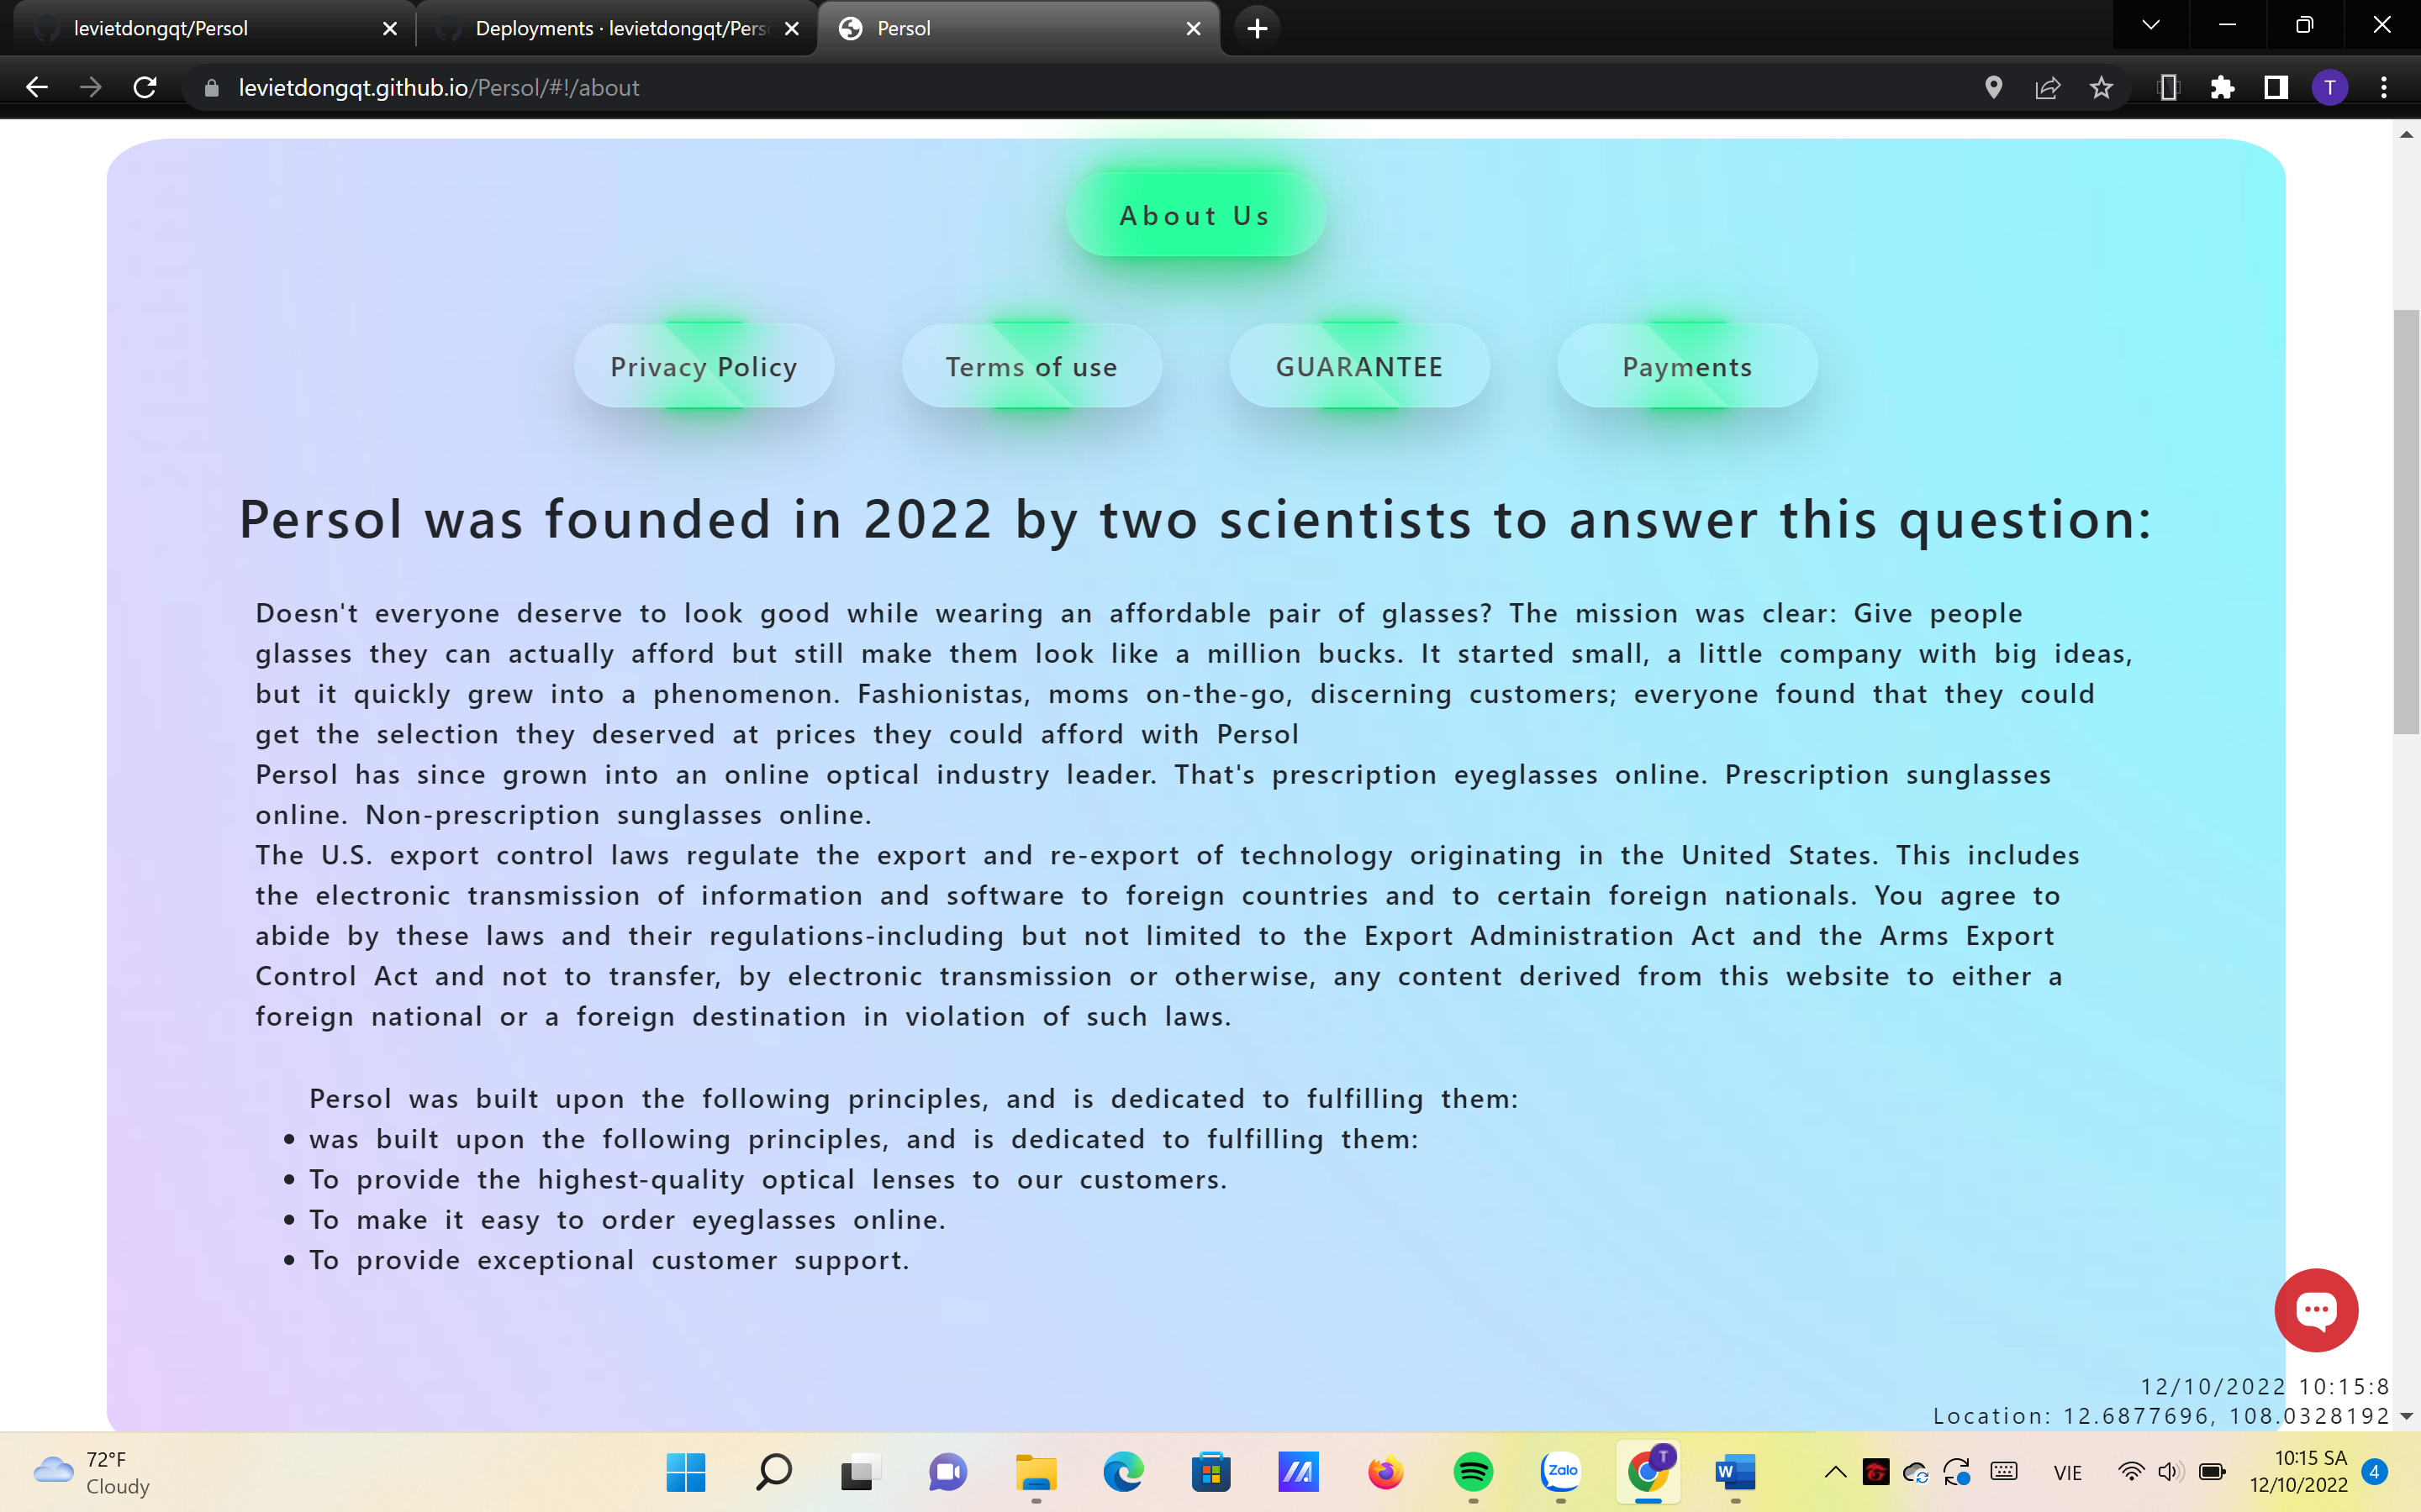

* Description:

The information of Glasses.com along with the form including the message that customer want to give the management team are given in this page. A google map about the location of the company is also provided here.

* Screen shot

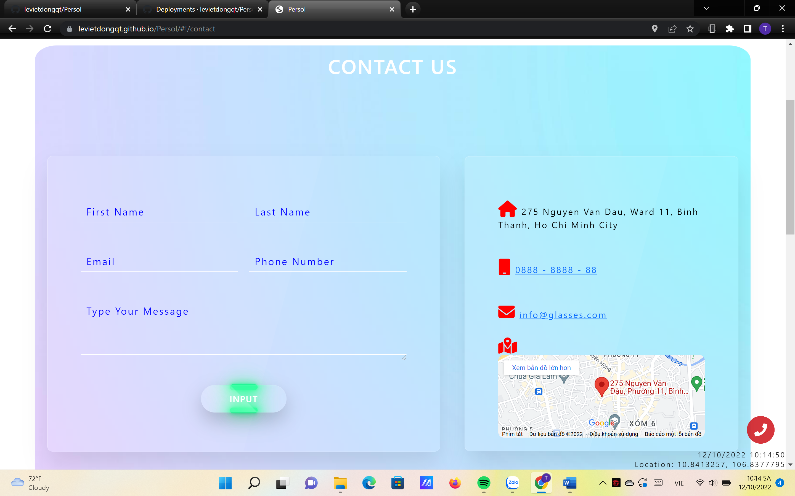

**HTML, CSS, JAVASCRIPT DESCRIPTION**

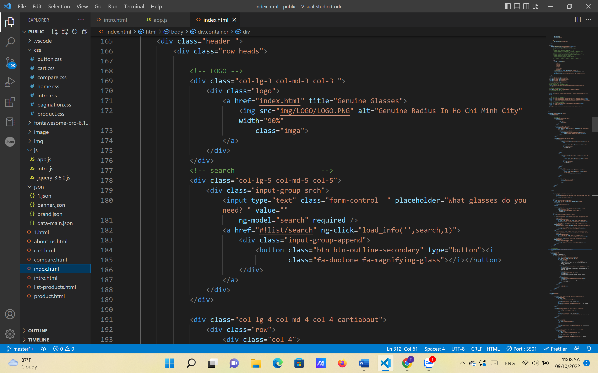

**Home page**

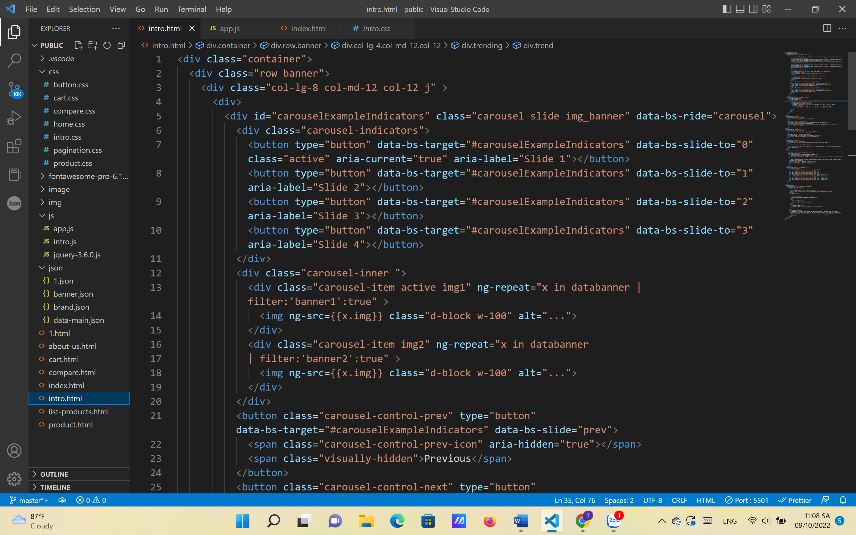

**Slideshow**

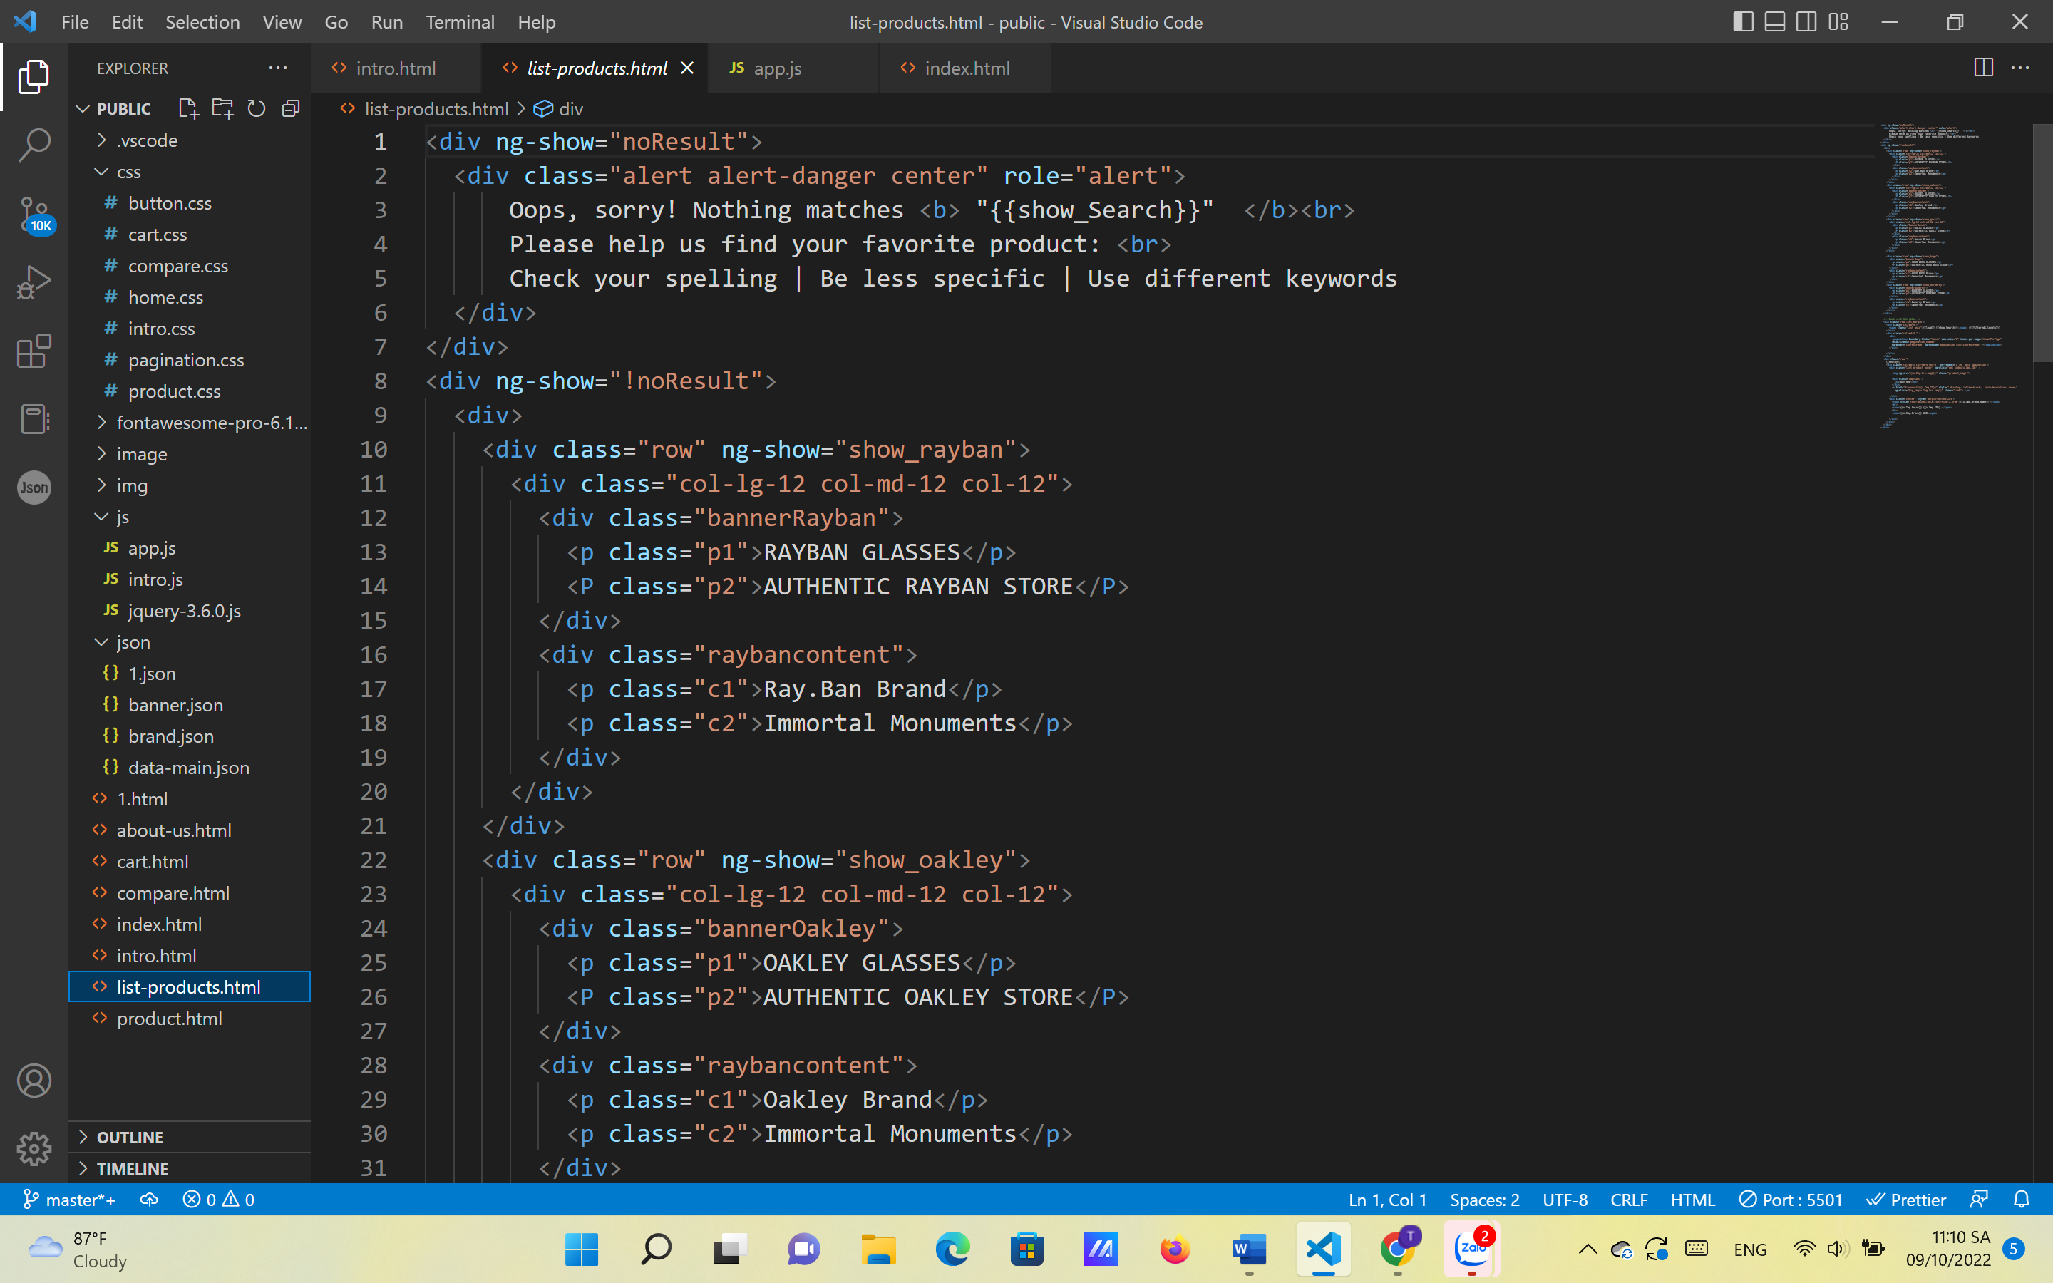

**Products page**

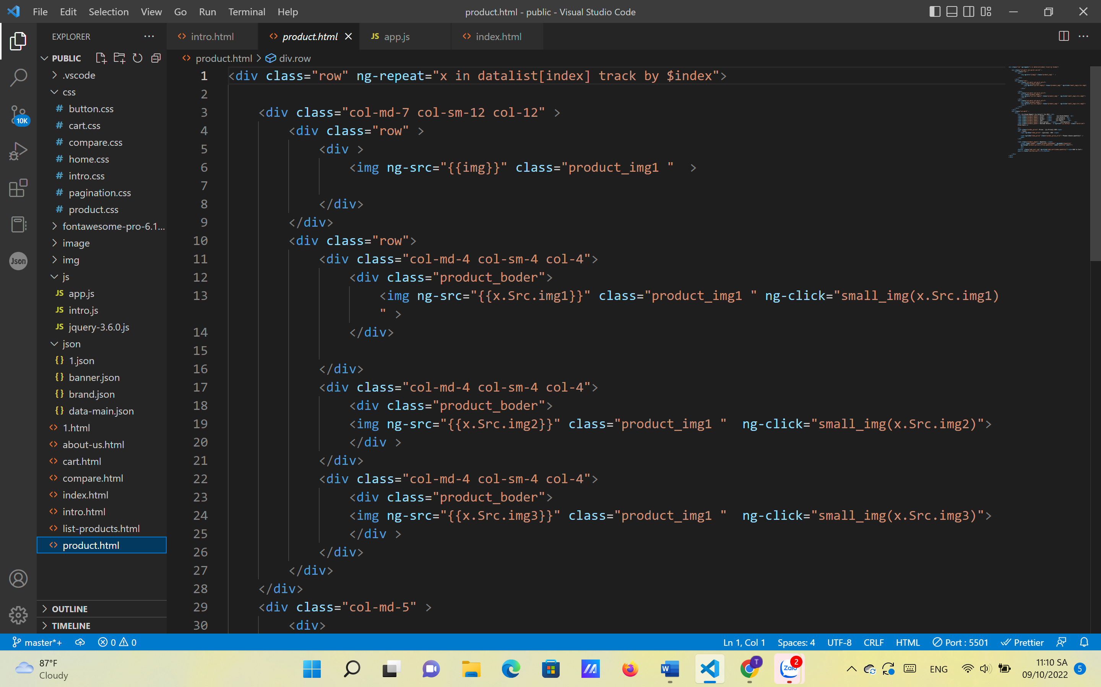

**Products detail page**

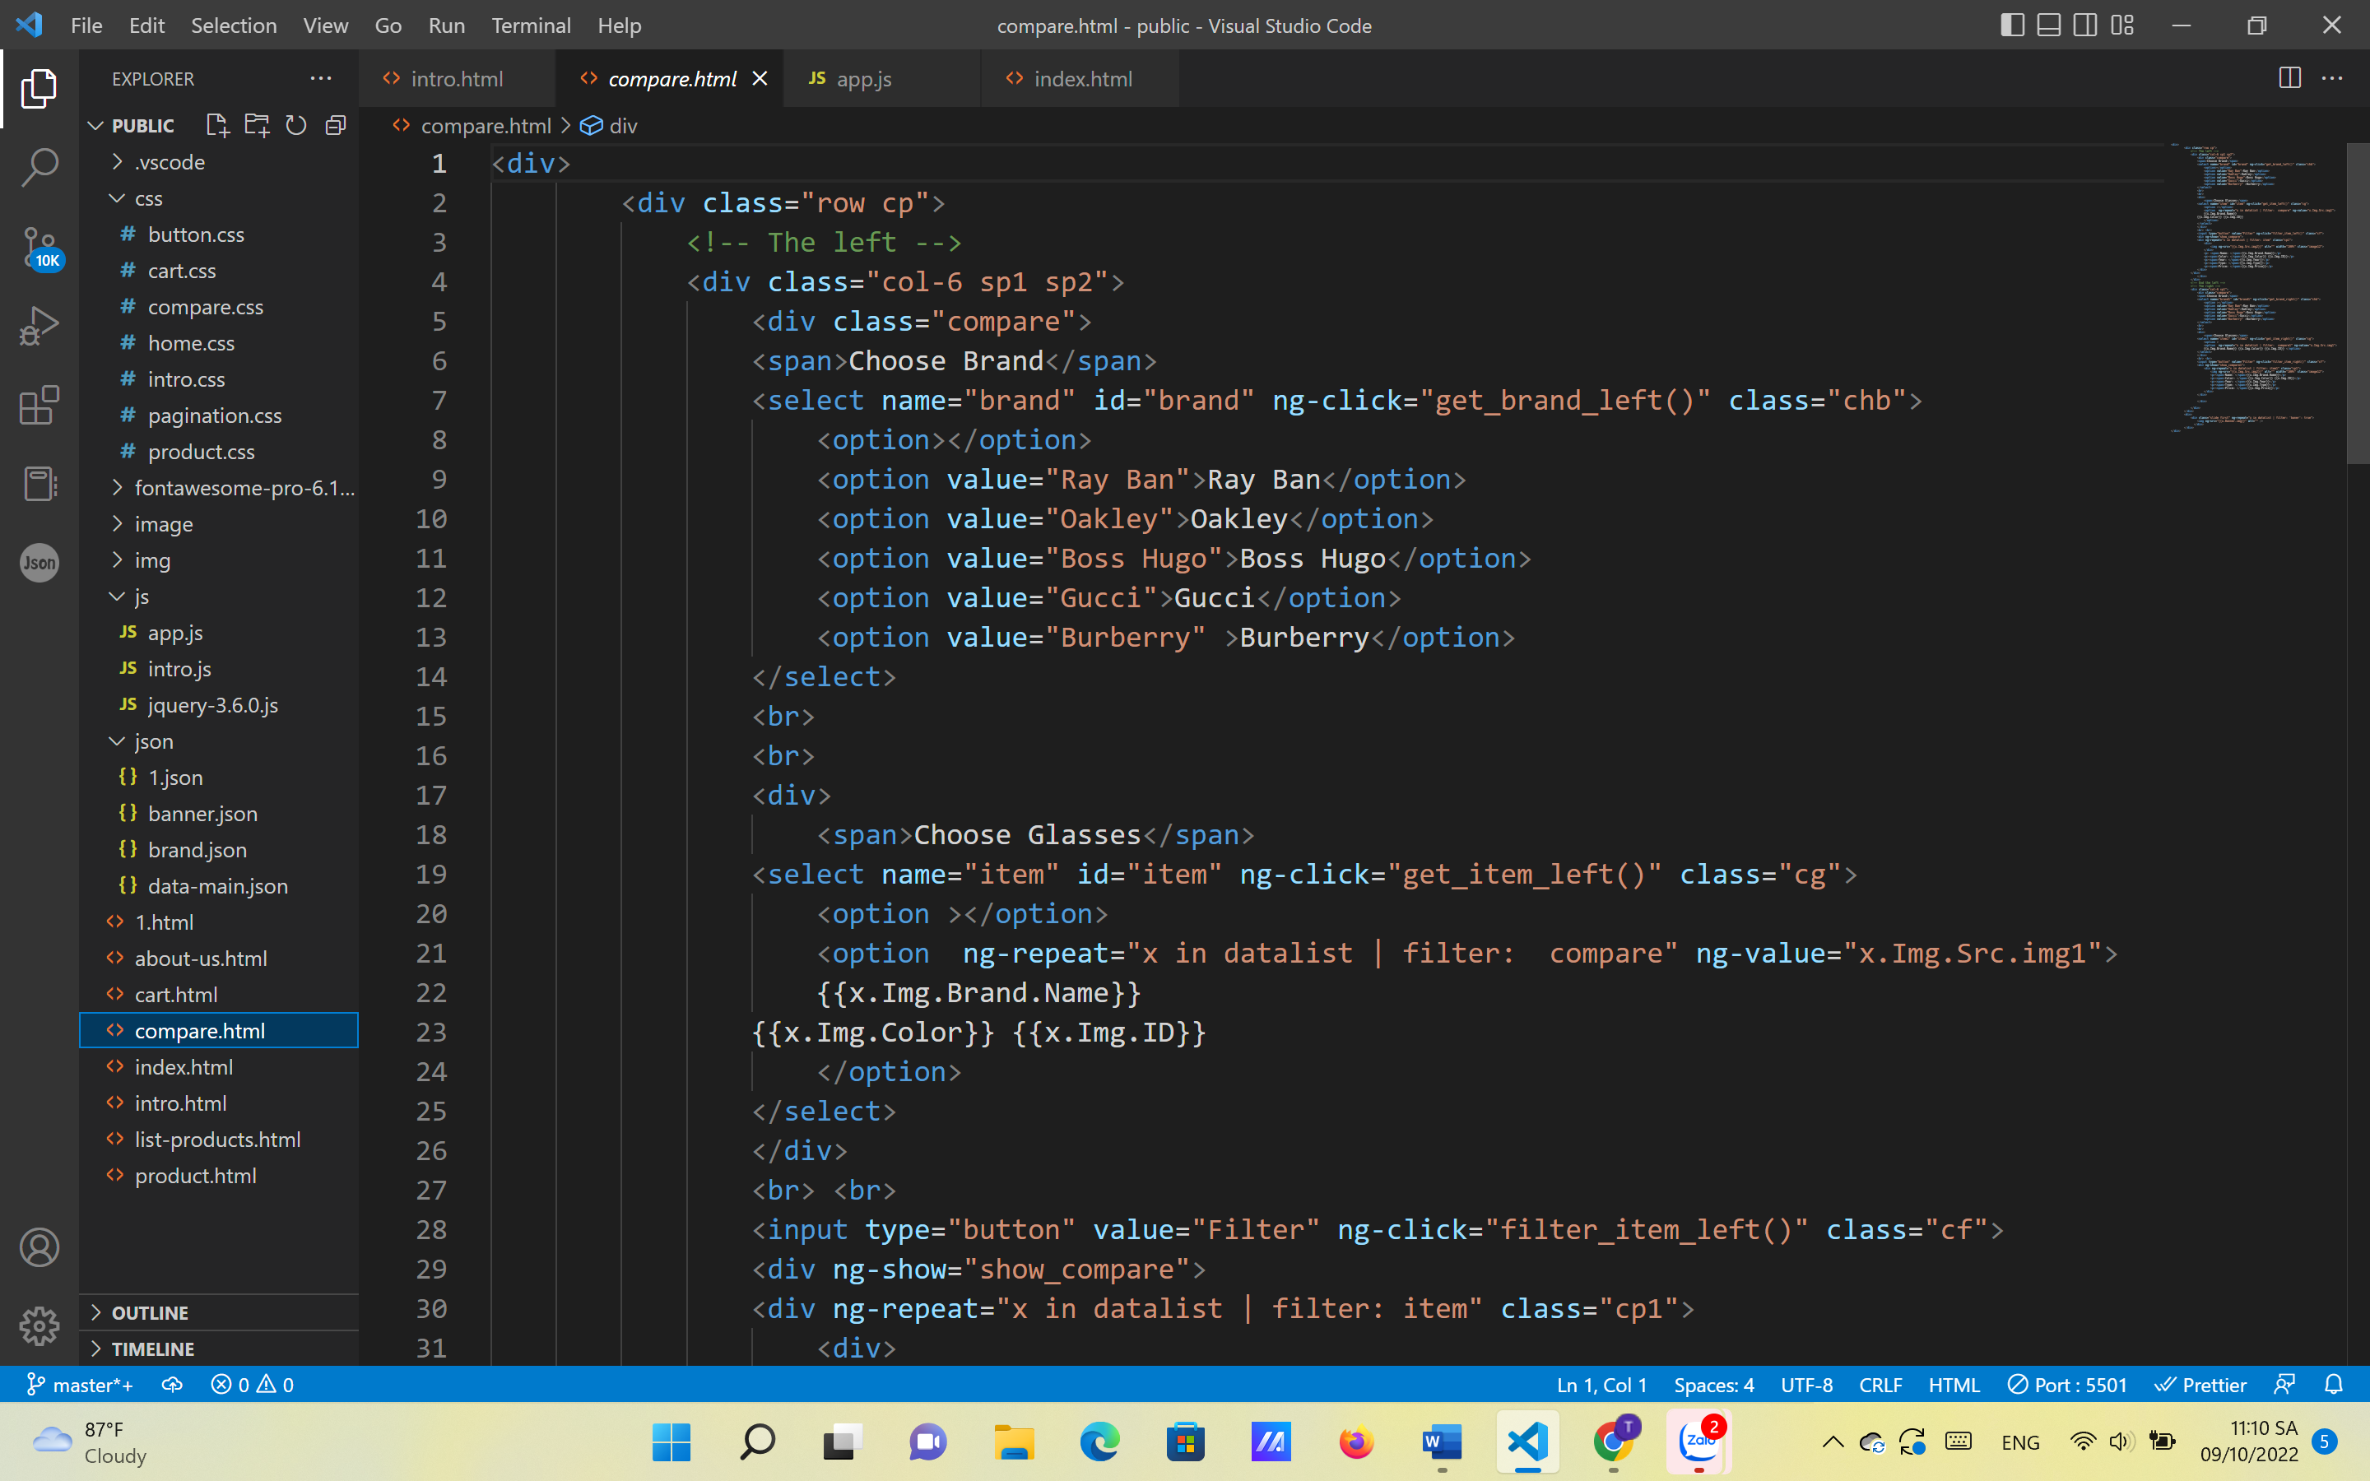

**Compare page**

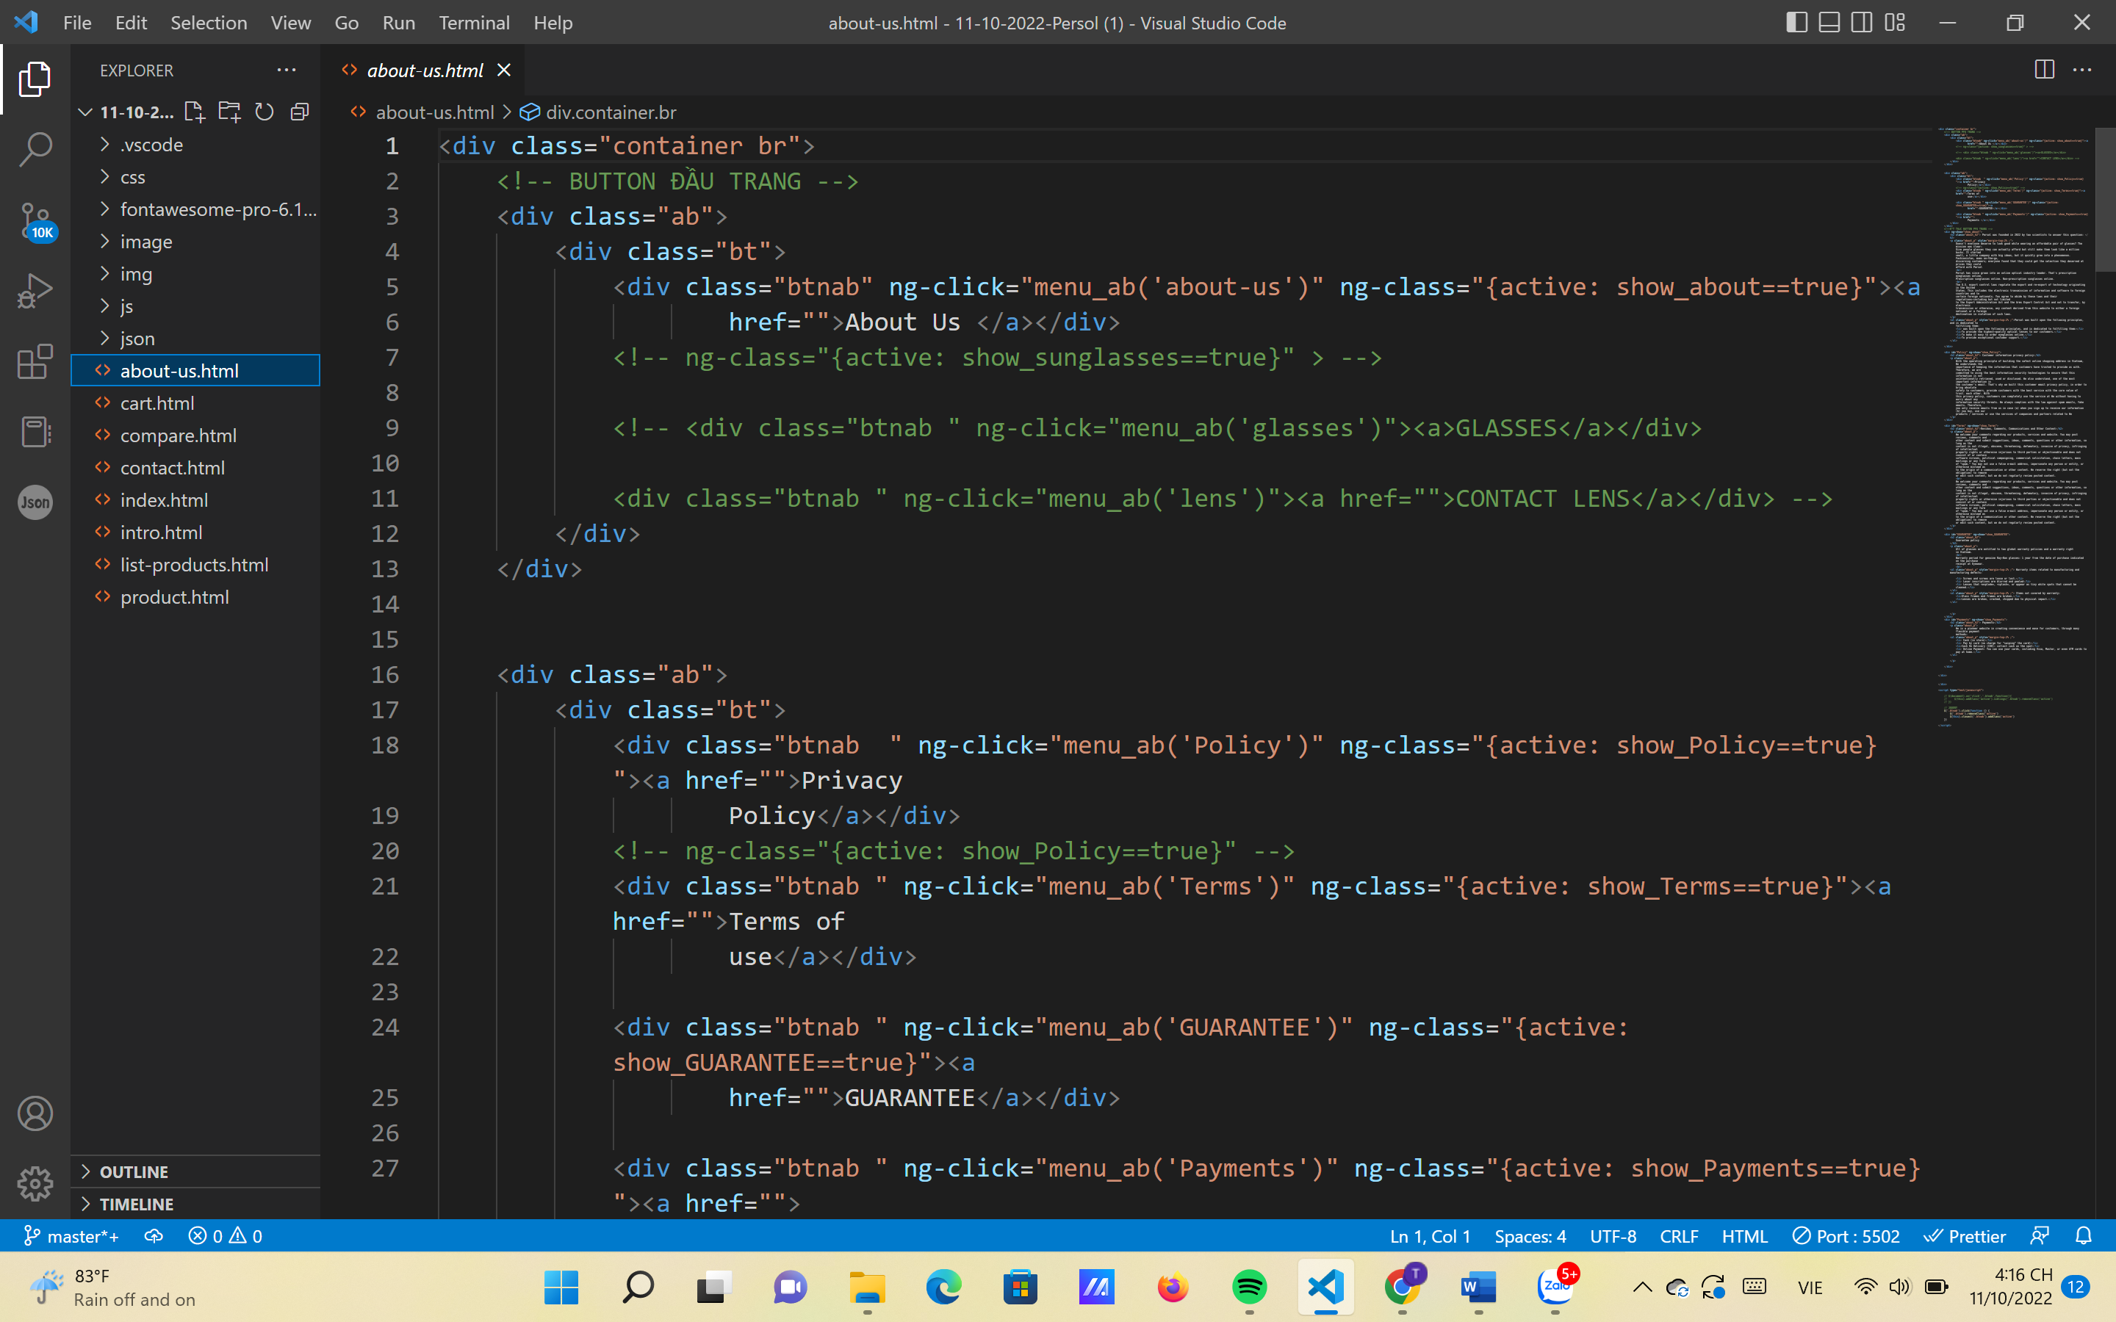

**About Us page**

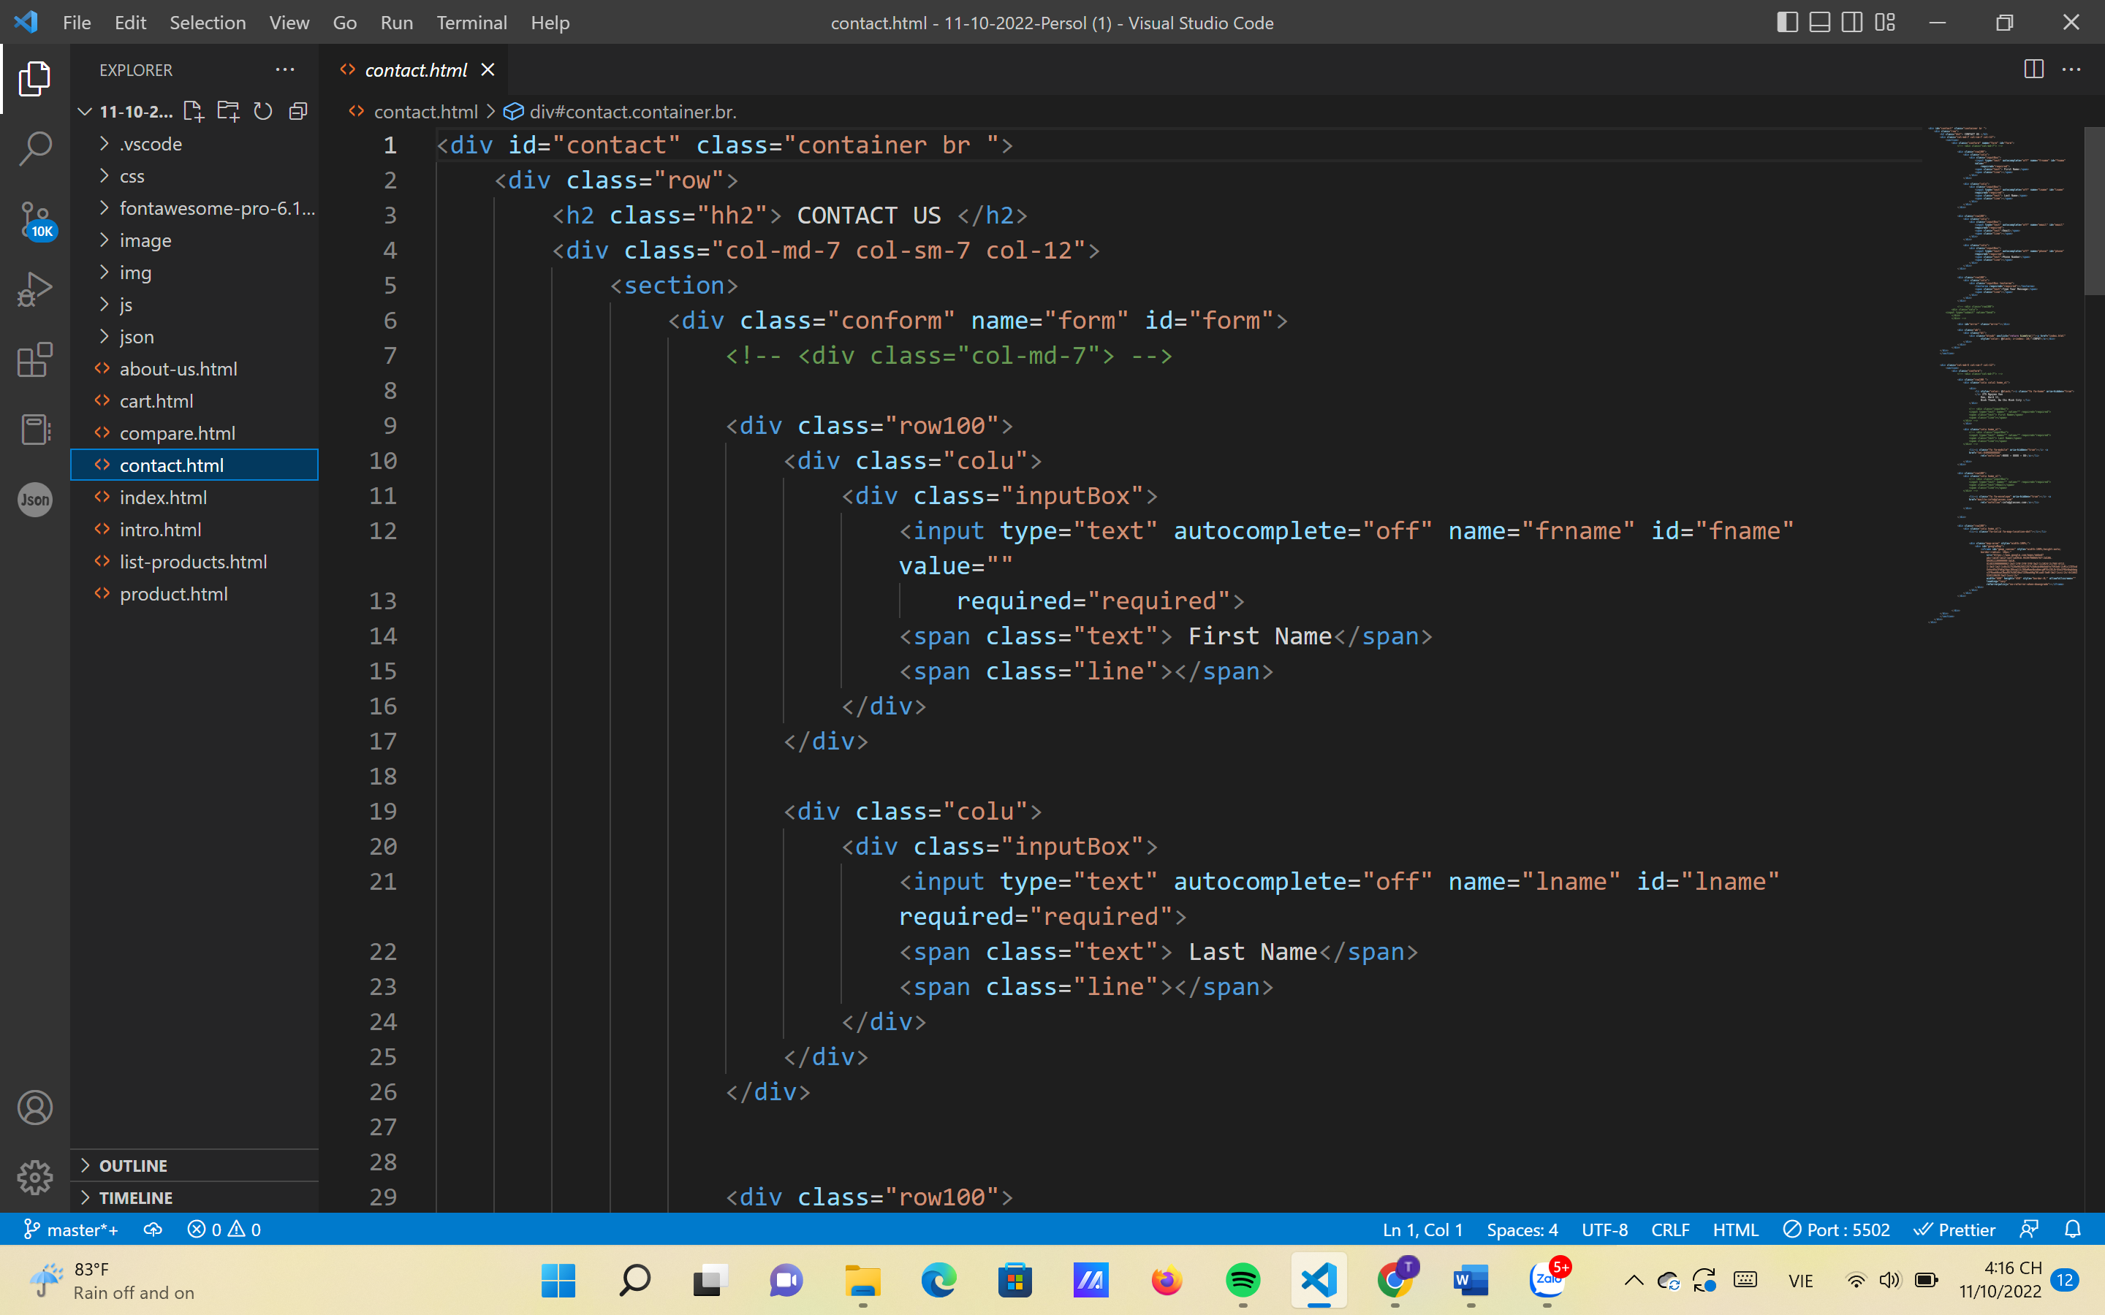

**Contact Us page**

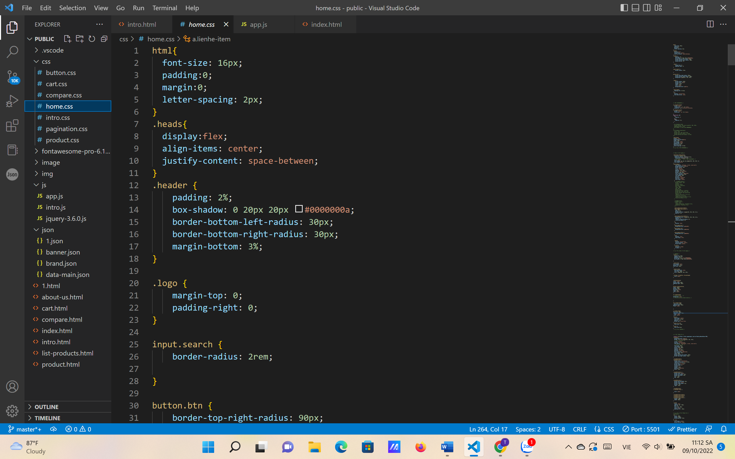

**Style.css**

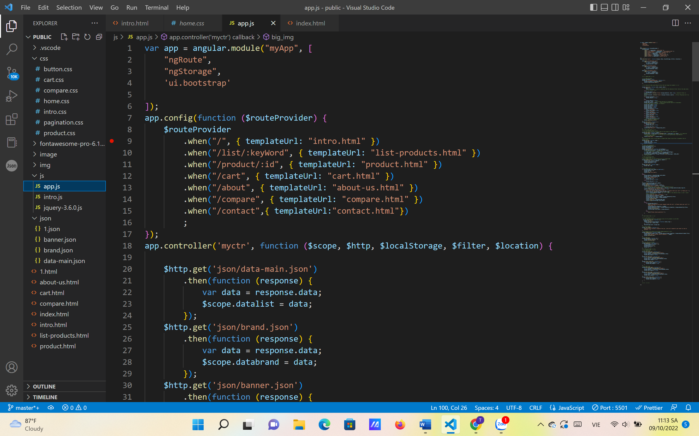

**app.js**

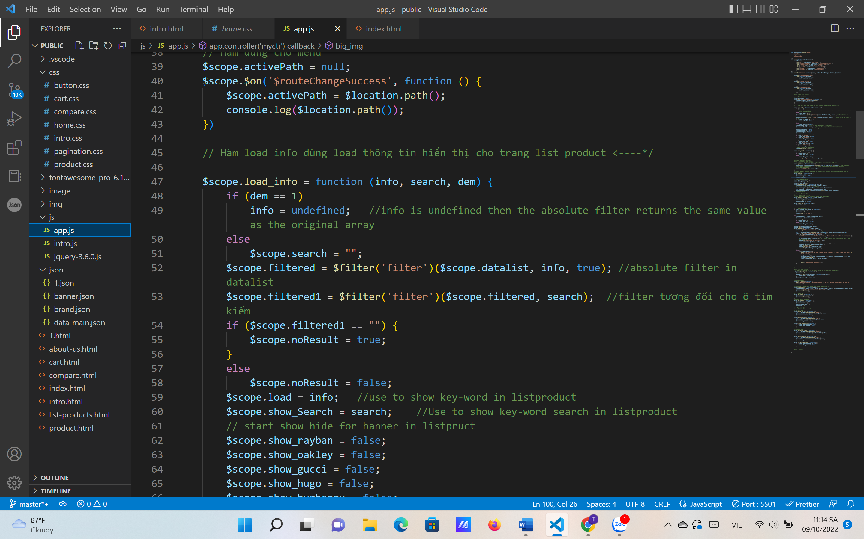

**One of the js files to run website**

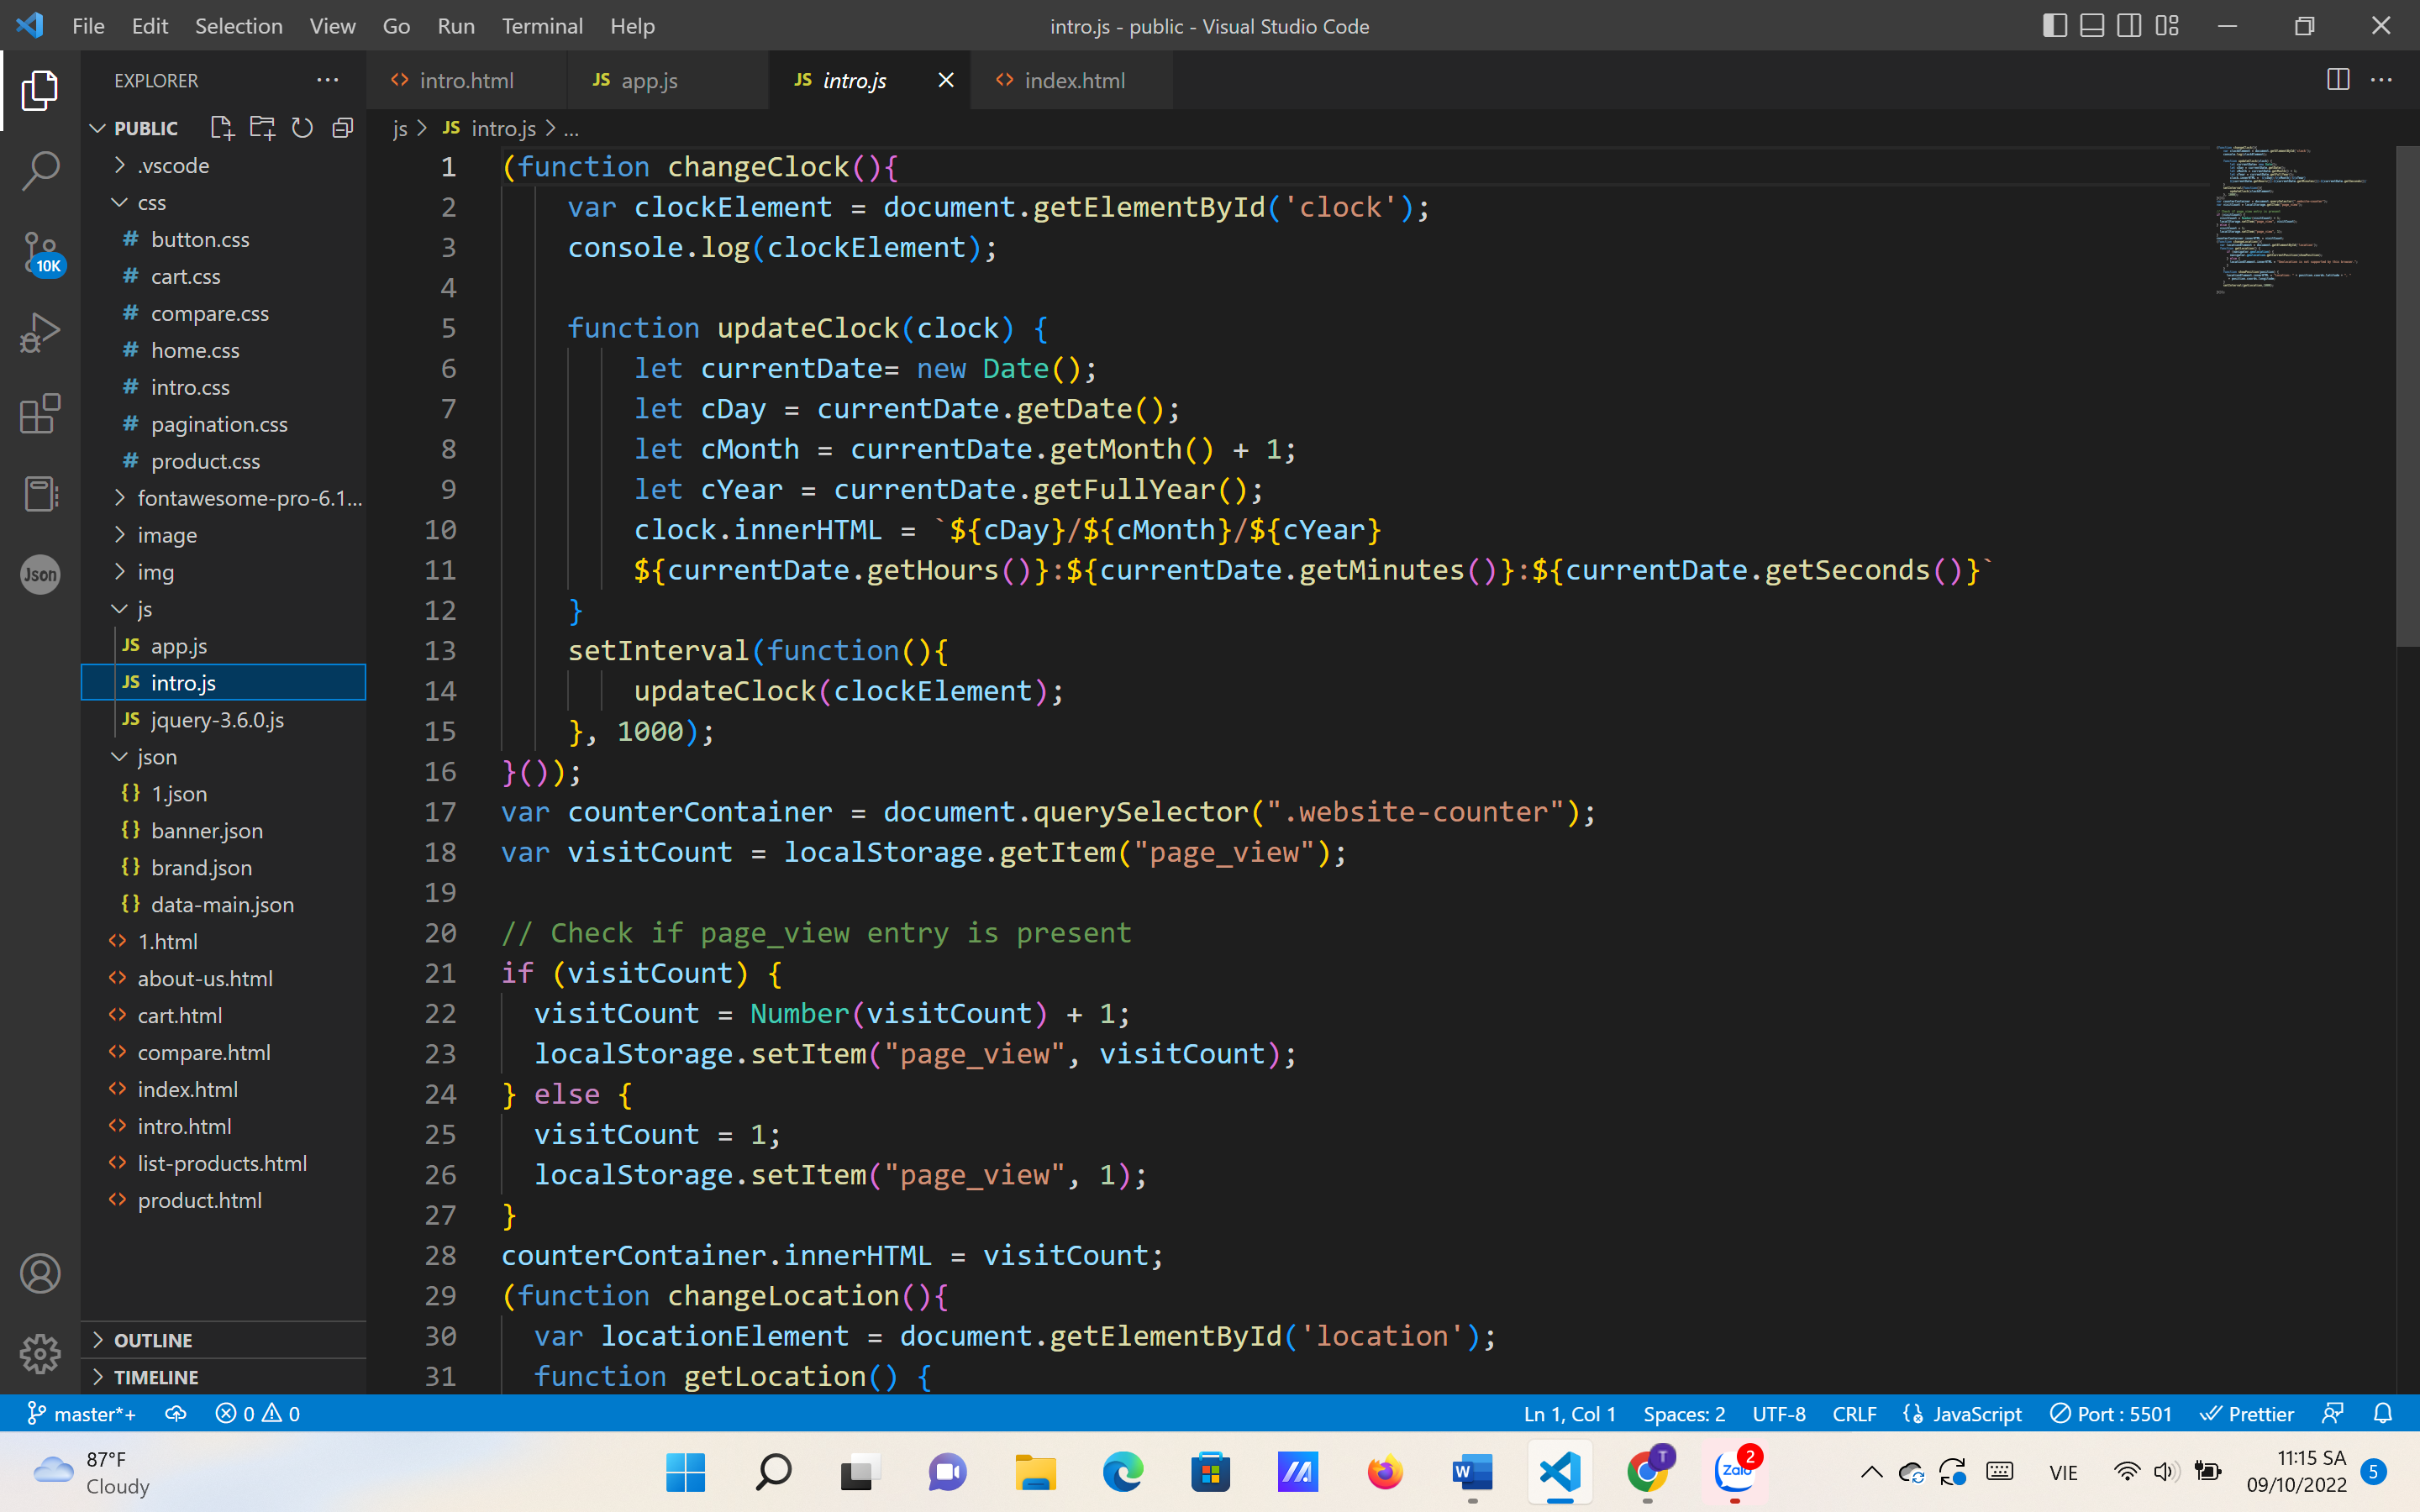

**Javascript about Time and Location**

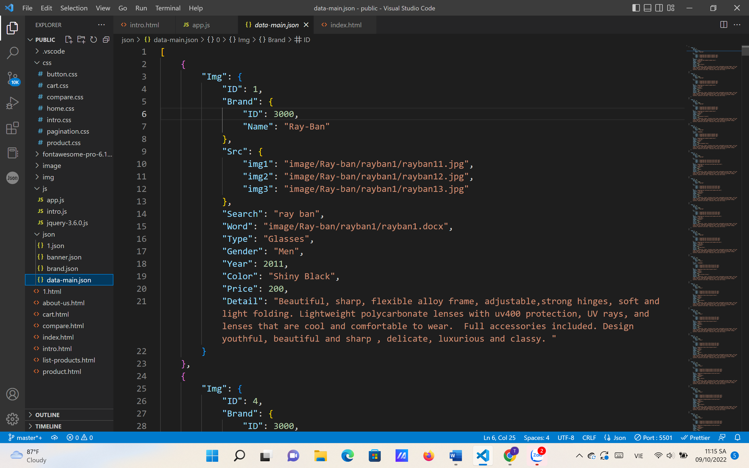

**json file**

# TASK SHEET REVIEW 3

|  |  |  |  |  |  |  |  |
| --- | --- | --- | --- | --- | --- | --- | --- |
| **Project Ref. No.:**  **eP/Advertisement**  **Portal Management System/01** | | **Project Title:** | **Activity Plan Prepared By:** | **Date of Preparation of Activity Plan:** | | | |
| **Sr.**  **No.** | **Task** | **Actual**  **Start Date** | **Actual Days** | **Team**  **Mate Names** | **Status** |
| 1 | Home page | Persol | Dong | 08-Oct-2022 | 1 | Huy | Completed |
| 2 | Category | 08-Oct-2022 | 1 | Dong | Completed |
| 3 | Brand | 08-Oct-2022 | 1 | Dong | Completed |
| 4 | Compare | 08-Oct-2022 | 1 | Phuoc | Completed |
| 5 | Contact us | 08-Oct-2022 | 1 | Phuoc | Completed |
| 6 | About us | 08-Oct-2022 | 1 | Phuoc | Completed |
| 7 | Json | 08-Oct-2022 | 1 | Dong | Completed |
| 8 | Live show | 08-Oct-2022 | 1 | Huy | Completed |
| 9 | Task sheet | 08-Oct-2022 | 1 | Huy | Completed |

|  |  |
| --- | --- |
| **Date: 09/10/2022** | |
| Signature of Instructor:  Tai  **Mr. Nguyen Phat Tai** | Signature of Team Leader:  Dong  **Mr. Le Viet Dong** |